Anexa nr. 1

la Hotărîrea Guvernului nr. ______

din ________________ 2017

**Security of Supply Statement**

**of the Republic of Moldova**



**Ministry of Economy**

**of the Republic of Moldova**

**Chisinau 2017**

**ACRONYMS**

|  |  |
| --- | --- |
| NAER | National Agency for Energy Regulation of the Republic of Moldova |
| CAIDI | Customer average interruption duration index |
| CHP | Combined heat and power plant |
| CSE | Central stockholding entity |
| ECT | Treaty Establishing the Energy Community (Energy Community Treaty) |
| EnC  ECS | Energy Community  Energy Community Secretariat |
| DSO  FEEN  GNFFE | Distribution system operator  Supply of electricity North JSC  Gas Natural Fenosa Supply of Electricity LLC |
| GoM | Government of Moldova |
| HPP | Hydro power plant |
| HV  IFIs | High voltage  International Financial Institutions |
| FCC | Foreign capital company |
| JSC | Joint stock company |
| LPA  LV | Local public authorities  Low voltage |
| LLC | Limited liability company |
| MC-EnC | Ministerial Council of the Energy Community |
| MDL  MGRES | Moldovan lei  Moldavskaya GRES (Power Plant in Transnistria) |
| MoE | Ministry of Economy |
| MPS | Moldovan power system |
| MV | Medium voltage |
| RED  RED Union Fenosa  RED North  RED North-West | Electric Distribution Networks  FCC RED Union Fenosa JSC  RED North JSC  RED Nord-West JSC |
| RES  RES-E | Renewable energy sources  Electricity From Renewable Energy Sources |
| RoM | Republic of Moldova |
| SAIDI | System average interruption duration index |
| SAIFI | System average interruption frequency index |
| SoS | Security of Supply |
| SE | State enterprise |
| TPP | Thermal power plant |
| TSO | Transmission system operator |

**Introduction**

1. The energy balance only for the right bank of RoM (without Transnistria)[1] for the last available year of 2015 is shown in Figures 1-4.

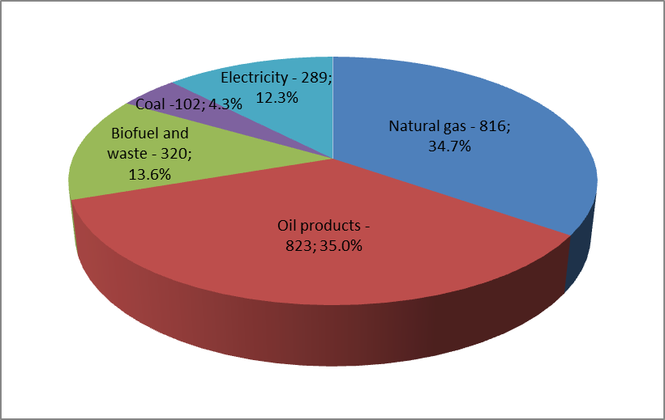

**Figure 1. Total primary energy supply by energy form (1000 toe; %)**

In total primary energy supply[2] of the country, oil products and natural gas are by far the predominant energy forms (35%, and respectively 34.7%). Natural gas is 100% imported from Russia (Gazprom), but oil products from Romania, Bulgaria, Russia and other country. Biofuels and waste represent 13.6% (in 2011 only 9.3%). Coal and electricity represent 4.3% and 12.3% respectively. Due to imports of primary energy resources the overall energy dependence of the RoM is very high about 88%.

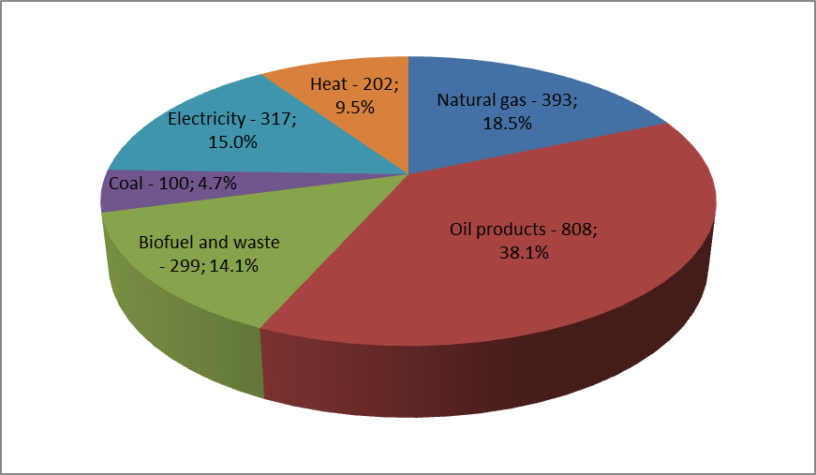

**Figure 2. Total final energy consumption by energy form (1000 toe; %)**

At the final energy consumption level, oil products represent by far the major share (38.1%) followed by natural gas (18.5%) and electricity (15.0%). Biofuel and waste has a share of 14.1%, heat supplied through district heating systems – 9.5% and coal – 4.7%.

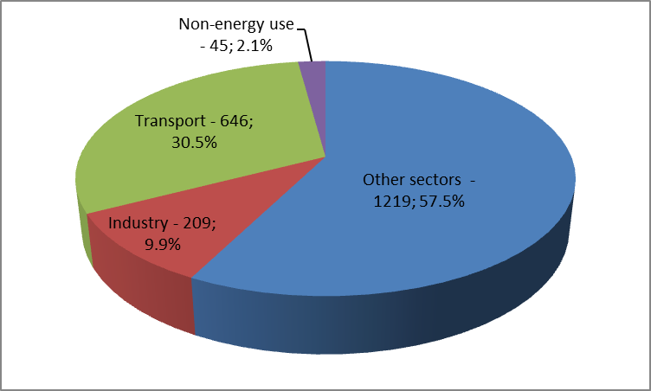

**Figure 3. Total final energy consumption of energy by sector (1000 toe; %)**

Final energy consumption by sectors demonstrates that 9.9% of energy is consumed by Industry, 30.5% by Transport and as much as 57.5% of energy is consumed by other sectors, the details of which are further shown in Figure 4.

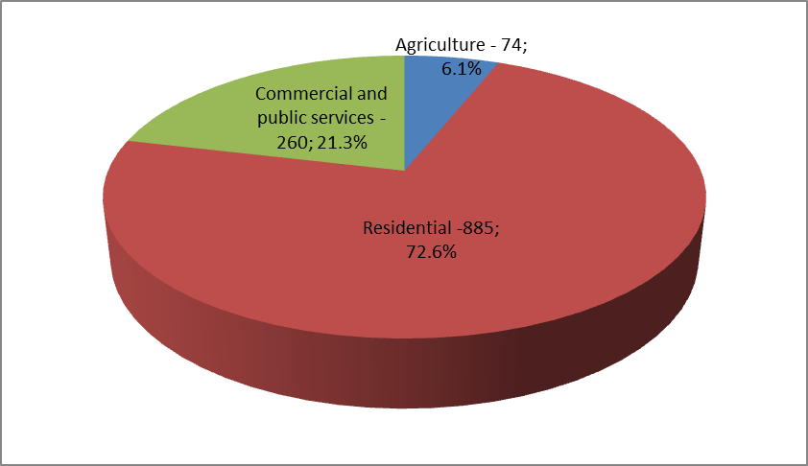

**Figure 4. Final energy consumption in Other sectors (1000 toe; %)**

The Other consumption sectors is dominated by the Residential sector which represents as much as 72.6% of total consumption by Other sectors, followed by Commerce and public services - 21.3% and Agriculture – 6.1%.

1. In general, the RoM energy sector is overwhelmed with difficulties. High dependence on imported gas and electricity, historical debts, outdated electricity generation and district heat production systems, inefficient district heating systems, together with tariffs set well below economic levels in the past, all contributed to the poor performance of the sector still today.
2. RoM is a transit country and a considerable importer of energy as aforementioned with only 12% of primary energy demand met from indigenous energy resources of the mainland. Such major energy dependence makes the country’s economy very vulnerable to any external disturbance in energy supply, energy price fluctuations with a major degree of unpredictability in the future. The prevailing situation also represents a threat for social security and a severe risk for the sustainable development of national economy in the future.
3. RoM is poor in energy resources. There are no reserves of coal and oil. Regarding renewable energy sources (RES), the potential is not fully exploited, especially the wind and solar, both, due to legal framework and technical systems constraints. Due to intensive activities in agriculture, biomass is regarded as one of the most important sources of renewable energy, which can be potentially exploited to an extensive degree for energy purposes.
4. According to the Energy Strategy of the RoM until 2030 ("Energy Strategy") the main energy sectors needing to be developed in the future remain the same, such as electricity, gas, district heating, renewable energy and energy efficiency.
5. The Moldovan electric power system is operated as part of the IPS/UPS (Figure 5) electricity system that is not synchronized with the ENTSO-E (UCTE) system of the other Energy Community (EnC) countries, which prevents the RoM to access the internal electricity market in the rest of EnC and further in EU, and represents a serious impediment for investments in power generation in the RoM and in reinforcement of the power grid towards EnC and EU.



**Figure 5. Major synchronous transmission grids in Europe and CIS**

1. There is quite poor diversification of primary energy supply as natural gas represents approx. 34.7% of the total primary energy supply of the country. Natural gas is supplied by Russia, through Ukraine and left bank of Moldova (Transnistria). It is predominantly consumed by energy companies in the central transformation sector (Power plant, CHPs, heat only plants) – 44.7%, followed by Industry - 7.3%, Residential sector – 28.9% and Commerce and public services – 10.4%.
2. The RoM is an important transit country/route for securing natural gas supply at the regional level (Russian gas via Ukraine and the RoM to Romania, Bulgaria, Turkey and FYR of Macedonia). In 2014, the construction of a new interconnection with Romania (Iasi-Ungheni) was completed, but to fully put into operation this interconnection, it is necessary also to build another gas pipeline: Ungheni – Chisinau, the construction of which is planned to begin in 2018.
3. Business operations in the natural gas sector are carried out by Moldovagaz JSC, where Gazprom JSC of Russian Federation is the major shareholder. Due to existence of a single source of import and supply of natural gas at regulated tariffs, according to the NAER Resolution No. 408 of 06.04.2011, the natural gas market in the RoM is considered as non-competitive.
4. In conditions of poor domestic energy resources, energy efficiency is a cornerstone of future energy strategy, because improvement of energy efficiency is one of the activities that can be controlled by the State itself. However, in order to safeguard progress and support sustainable development, the country needs a very strong institutional framework, to be obtained through a well-argued administrative reform, capacity building and development mechanisms in place and, last but not least, a development partners support for development of policies and plans and their implementation, being assisted by development partners.

Regarding energy efficiency policies, the first National Energy Efficiency Action Plan (NEEAP) for the period 2013-2015 was adopted in February 2013. Government adopted in December 2016 the second NEEAP for the period 2016-2018, which already replaces the first NEEAP. The Energy Efficiency Fund was established in June 2012, with the aim to promote, develop and financially support investment projects in the area of energy efficiency and renewable energy sources.

Regarding renewable energy sources (RES), according to available data, the overall technical potential of RES is estimated at 113.4 PJ, of which solar (50.4 PJ) and wind (29.4 PJ) represent about 70% of the total RES potential, while the rest is biomass (21.5 PJ or 19%) and hydro (12.1 PJ or 11%). However, it still has to be studied which technologies are suitable to enter the renewable energy market or to be promoted via the state-driven incentive schemes in order not to endanger technical stability of the Moldovan power system (MPS) as well as not to entail too high electricity tariffs increases which would cause social problems and/or not be justifiable from the macro-economic viewpoint of the RoM.

1. This report is based on the date and information available for 2015 year that include only the right bank of the Nistru River (mainland) taken from annual reports of the National Bureau of Statistics and NAER.
2. **Electricity**

**12.** The description given in this section will be made only for the electricity sector of the RoM without Transnistria, given that the electricity sector of this region is not monitored by Moldovan state institutions. It has to be mentioned that only two electricity market participants from the Transnistrian region requested and obtained licenses from NAER: one license for electricity production for MGRES and a supply license for Energokapital JSC.

### 1.1. Key market players and description of their role

**13.** Apart from the executive branch of state administration powers designated to Government of Moldova (GoM), the line ministry responsible for energy is *Ministry of Economy* (MoE), which according to the Law on Energy is responsible for energy sector administration and being primarily in charge of energy sector policies and legal framework development. As a *Central Government Authority***,** the MoE is also in charge of SoS of energy (electricity, gas, oil, district heating etc.). Other responsibilities of MoE include:

* 1. elaboration and promotion of state policies and strategies in energy sector;
  2. elaboration of concepts and programs on energy sector development;
  3. monitoring the implementation of development and investment programs;
  4. elaboration of normative documents in the field of energy;
  5. development of international energy relations, including on acquisition of strategic energy resources, attracting investments, development of energy interconnections, and development of the energy market;
  6. management of state energy property;
  7. supporting competition and limiting the monopolistic presence in the energy sector.

Related to SoS, the MoE elaborates and implements measures to ensure the energy security in the country.

**14.** NAER is a public regulatory authority having the status of a legal entity which is not subordinated to any other public or private authority. NAER as an independent public authority, that supports introduction of market mechanisms in the energy sector and regulates the sector while protecting the interests of customers and investors, has the following basic competences:

1. supervises compliance with laws and regulations in the energy field;
2. promotes and ensures fair competition and efficient operation of energy markets, monitors the level and effectiveness of market opening and competition in wholesale and retail energy markets;
3. issues licenses for activities on energy market (according to Law on Natural Gas, Law on Electricity, Law on thermal energy and promotion of cogeneration, Law on promotion of use of renewable energy and Law on Petroleum Products Market);
4. monitors compliance with the license conditions and applies the provisions of the laws listed above;
5. monitors investment plans of system operators;
6. sets and approves standards and requirements for distribution and transmission services and supply activities;
7. promotes adequate tariff policy following the interest of both producers and customers;
8. approves regulated tariffs calculated based on approved methodologies and monitoring of their application;
9. supervises the application of necessary and justified costs principle by regulated operators for regulated activities;
10. supervises the customers’ rights and protection, etc.

The specific role of NAER in achieving SoS is in approving costs of power system maintenance and planed investments by transmission and distribution companies.

**15.** The *Competition Council* is the authority for safeguarding that provisions of the Law on Competition are implemented properly.

**16.** On the other side is the power industry. The key market players are power system undertakings–legal entities are:

**16.1.** Generation:

1. *Termoelectrica SA* in Chisinau;
2. *CET-Nord SA* in Balti;
3. *SE Nodul Hidroenergetic Costesti* (HPP Costesti – regulated producer);
4. MGRES;
5. CHPs in sugar industry (not regulated).
6. 17 small power plants that generate electricity from RES (RES-E), (producers at regulated tariffs).

Termoelectrica SA and CET Nord SA are regulated producers of electricity and thermal energy.

**16.2.** Transmission (incl. central dispatch): *SE* *Moldelectrica* is the state-owned single power transmission system operator (TSO) of RoM, which is specialized in centralizing the transport services and operative dispatching of energy system of RoM.

SE Moldelectrica manages the internal transmission network on the right bank of the Nistru River. With respect to SoS, the TSO is typically responsible for:

* 1. Ensuring ancillary services (reserve, load-frequency control and balancing energy) required for operation of the power system;
  2. Dispatching of power system;
  3. Congestion management;
  4. Purchasing energy for covering transmission system losses;
  5. Development and maintenance of power transmission system;
  6. Connection/disconnection to/from the grid of system users.

Transmission activity including tariff is regulated by NAER.

**16.3.** Distribution consists of 3 distribution system operators (DSO): *RED North, RED North-West*  (both state-owned) and *RED Union Fenosa* (privately-owned), the latter covering about 70% of the territory of Moldova (without Transnistria) With respect to SoS, the DSOs are typically responsible for:

1. Ensuring balancing energy required for their customers;
2. Dispatching of power generation units connected to the distribution system;
3. Purchasing energy for covering distribution system losses;
4. Development and maintenance of power distribution system;
5. Connection/disconnection to/from the grid of system users.
   1. Supply at regulated tariffs:
6. FCC "Gas Natural Fenosa Furnizare Energie" LLC (GNFFE) that was created as a result of unbundling of activities by FCC RED Union Fenosa JSC (separation of distribution and supply activities), in accordance with the Law on electricity (transposing the EU Directive 2003/54/EC);
7. JSC "Furnizarea Energiei Electrice Nord" that was created as a result of unbundling of activities by RED North and RED North-West (separation of distribution and supply activities).

Both companies act as suppliers of last resort in their respective supply areas.

* 1. Supply at non-regulated tariffs:

1. *Energocom JSC* is a state-owned electricity supplier and trader on the wholesale market in charge of managing electricity import contracts with Ukraine;
2. *Energokapital JSC, s*upply Company from Transnistria, that supplies electricity produced by MGRES to Energocom JSC.
3. Other 10 suppliers currently licensed by NAER. However, these suppliers are not active on the electricity market.

**16.6.** Mixed (network/generation) functions: are performed by *Dnestrenergo JSC* Company of Transnistria that operates Eastern (left bank of Nistru River) electricity networks and HPP Dubasari, which is not regulated by Moldovan institutions;

**16.7.** Final customers: since January 1, 2015 all final customers are declared eligible and have the right to buy electricity from any generator or supplier, including from abroad.

In summary, on the electricity market of RoM there are 4 licensed generators, 1 transmission system operator, 3 distribution system operators, 2 suppliers at regulated tariffs, 13 suppliers at non-regulated tariffs, and 17 RES –E (producers of electricity from RES) at regulated tariffs.

### 1.2. Relevant basic legal and regulatory framework in the sector

**17.** In order to promote development of the electricity sector, the legal framework was developed constantly during the last years having a clear objective to align it to the European framework and relevant *acquis* on electricity of Energy Community.

**18.** Law on electricity No. 107 of May 27, 2016 that transposed the EU Directive 2009/72/EC concerning common rules for the internal market in electricity and repealing Directive 2003/54/EC (Third Energy Package) and thus created the necessary framework for its implementation, particularly by:

1. Defining respective competences of governmental authorities, and the objectives, duties, powers, and rights of NAER;
2. Defining the tasks, rights and responsibilities of producers, transmission system operators, distribution system operators and electricity suppliers;
3. Defining concept of public service obligations and basic rules for imposition of such obligations, which may relate to security, including security of supply, regularity, quality and price of supplies and environmental protection, including energy efficiency, energy from renewable sources and climate protection;
4. Unbundling, designation and certification and independence of transmission system operator and distribution system operators;
5. Network development and powers to make investment decisions
6. Define the concept of customer protection, and first of all, of vulnerable customers which may refer to energy poverty;
7. Defining market organization, market liberalization and third party access to the transmission and distribution systems, etc.

**19.** A new Law on promotion of the use of renewable energy, which transposed the EU Directive 2009/28/EC of 23 April 2009 of the European Parliament and of the Council on the promotion of the use of energy from renewable sources and amending and subsequently repealing Directives 2001/77/EC and 2003/30/EC was adopted on February 26, 2016. The new RES law is important for RES-E issues, which can also have an impact to the SoS of electricity.

**20.** The Law on heat and promotion of cogeneration was adopted on May 29, 2014 and partially transposed Directive 2012/27/EU of the European Parliament and of the Council of 25 October 2012 on energy efficiency, which amends Directives 2009/125 /EC and 2010/30/EU and repealed Directives 2004/8/EC and 2006/32/EC. This law also provides the transfer of certain regulatory competences in the heating sector (like approval of tariffs for activities in the heating sector) from Local authorities to NAER.

**21.** Apart from primary legislation, there are a number of secondary normative acts approved by NAER, in particular on issues like licensing, market rules, investments, tariffs, consumer protection, access and connection to electricity network, contracting, supply and billing of energy, guarantees of origin, etc.

**22.** Following the adoption of the Law on electricity No. 107 from May 27, 2016 and the new Law on promotion the use of renewable energy, some existing normative acts, approved by NAER have to be amended and modified to comply with the new primary legislation, and several new normative acts have to be developed and enforced in order to ensure a proper implementation of these laws.

### 1.3. Electricity balance (2013-2015)

**23.** Selected elements of electricity balance for the last 3 years (2013-2015) are shown in Table 1.

**Table 1. Electricity balance of 2013-2015**

|  |  |  |  |  |  |  |  |
| --- | --- | --- | --- | --- | --- | --- | --- |
| **SN** | **Category** | **2013** | | **2014** | | **2015** | |
| GWh | % of total | GWh | % of total | GWh | % of total |
| **1** | **Local production -total** | **747,9** | **18,3** | **788,2** | **19,1** | **792,8** | **19,1** |
|  | of which: |  |  |  |  |  |  |
|  | *Termoelectrica (CHP-1 and CHP-2)* | *647,3* | ***15,9*** | *660,4* | ***16,0*** | *670,5* | ***16,1*** |
|  | *CHP North* | *49,4* | ***1,2*** | *50,1* | ***1,2*** | *53,2* | ***1,3*** |
|  | *HPP Costesti* | *44,6* | ***1,1*** | *58,3* | ***1,4*** | *49,8* | ***1,2*** |
|  | *Sugar industry* | *4,7* | ***0,7*** | *16,2* | ***0,4*** | *2,2* | ***0,1*** |
|  | *RES* | *1,9* | ***0,5*** | *3,2* | ***0,1*** | *17,1* | ***0,4*** |
| **2** | **Purchases and Imports - total** | **3331,2** | **81,7** | **3341,5** | **80,9** | **3360,1** | **80,9** |
|  | of which from: |  |  |  |  |  |  |
|  | *MGRES* | *1875,5* | ***46,0*** | *2610,8* | ***63,2*** | *3342,5* | ***80,5*** |
|  | *Ukraine* | *1455,7* | ***35,7*** | *730,7* | ***17,7*** | *17,6* | ***0,4*** |
| **3=2+1** | **Total available for the system (gross consumption)** | **4079,1** | **100** | **4129,7** | **100** | **4152,9** | **100** |
| **4** | **Purchased - total** | **4079,1** | **100** | **4129,7** | **100** | **4152,9** | **100** |
|  | of which by: |  |  |  |  |  |  |
|  | *RED Union Fenosa* | *2941,9* | *72,1* | *2981,7* | *72,2* | *237,6* | *5,7* |
|  | *GNFFE* |  |  |  |  | *2730,7* | *65,8* |
|  | *RED North* | *662* | *16,2* | *689,7* | *16,7* | *436,2* | *10,5* |
|  | *RED North-West* | *355,8* | *8,7* | *363,3* | *8,8* | *236,5* | *5,7* |
|  | *FEEN* |  |  |  |  | *363,7* | *8,8* |
|  | *SE Moldelectrica* |  |  |  |  | *45,8* | *1,1* |
|  | *Eligible customers* | *112,2* | *2,8* | *87,6* | *2,1* | *94,6* | *2,3* |
|  | *Termoelectrica* | *7,2* | *0,2* | *7,4* | *0,2* | *7,8* | *0,2* |
| **5** | **Electricity consumption - total** | **3551,4** | **100** | **3645,9** | **100** | **3717,2** | **100** |
|  | of which: |  |  |  |  |  |  |
|  | a) Non-households customers -total | 1946,2 | 54,8 | 1989,7 | 54,6 | 2053,8 | 55,3 |
|  | b) Households customers | 1605,2 | 45,2 | 1656,2 | 45,4 | 1663,4 | 44,7 |
|  | ***or by electricity supplier:*** |  |  |  |  |  |  |
|  | *RED Union Fenosa* | *2550,3* | 71,8 | *2626,1* | 72,0 |  |  |
|  | *GNFFE* |  |  |  |  | *2684,3* | 72,2 |
|  | *RED North* | *579,7* | 16,3 | *613,7* | 16,8 | *368,7* | 9,9 |
|  | *RED North-West* | *305,2* | 8,6 | *313,5* | 8,6 | *199,6* | 5,4 |
|  | *FEEN* |  |  |  |  | *363,7* | 9,8 |
|  | *Eligible customers* | *109,0* | 3,1 | *85,2* | 2,3 | *93,1* | 2,5 |
|  | *Termoelectrica* | 7,2 | 0,2 | 7,4 | 0,2 | 7,8 | 0,2 |
| **6** | **Losses -total** | **527,7** | **12,9** | **483,8** |  | **435,7** |  |
|  | of which: |  |  |  |  |  |  |
|  | Transmission losses | 117,0 | 2,9 | 112,5 | 2,7 | 110,1 | 2,7 |
|  | Distribution losses | 410,7 | 10,4 | 371,3 | 9,2 | 325,6 | 8,1 |
| **7=3-5-6** | **Difference** | **0** |  | **0** |  | **0** |  |

**24.** In the period of 2013-2015, in RoM electricity consumption has been permanently increasing. In 2013 consumption increased by 2.1% vs. 2012, in 2014 by 2.7% vs. previous year and in 2015 by 2% vs. 2014. During this period the electricity consumption increased by 6.8% (2015 vs. 2012). The most important increase in electricity consumption was registered in the non-household sector - 7.8%. The consumption of household customers in this period increased by 5.6%.

**25.** All the demand for electricity during this period was covered by local production and import. Local yearly production in this period was about 745-793 GWh. In this context, it is necessary to take into account that the local production of electricity remains far below the consumption level, the domestic production (the right bank of Nistru river) covering only 19% of the demand, remaining at the same level as in the previous years. Such situation denotes a state of increased electricity dependence and vulnerability in terms of SoS, despite the fact that in this period, domestic production grew steadily. In 2014 local production increased by 5.4% compared to 2013, while in 2015 - by 0.6% vs. the previous year. The highest growth in local electricity production was registered by RES-E producers: from 1,9 GWh to 17,1 GWh (more than 9 times). As in the previous periods, the main share of local production belongs to the CHP producers (more than 91%).

**26.** The rest of electricity demand is generally covered by imports from Ukraine and acquisitions from MGRES. In this period from MGRES comes about 77.7% of remaining electricity demand, or 63.3% of total RoM demand. From Ukraine in 2013-2015 were imported 2204 GWh (20.2% of remaining demand or 17.8% of total demand). But, given the energy crisis in Ukraine, in 2014 the import from this country has been in a sharp decline. So, in 2014 import of electricity from Ukraine amounted to only 730.7 GWh, which is 2 times less than the amount of electricity imported in 2013. In 2015 imports from Ukraine practically were stopped and amounted only to 17.6 GWh (0.4% of RoM demand). It should be noted that electricity imported from Ukraine is primarily for power system balancing purposes as there is no suitable and sufficient power generation capacity in the RoM to provide the necessary system reserves and balancing energy. Therefore electricity imports from Ukraine are very important for the RoM in terms of SoS.

**27.** Unfortunately, this situation can be improved very little over at least the next medium-term of 3-5 years. Due to poor natural energy resource endowment of the country with fossil fuels and geopolitical position of the country apart from limited harnessing of energy from renewable sources for electricity production, the Energy Strategy 2030 does not envisage any diversification of fuels in power generation by 2030.

**28.** Another risk for the SoS is quite limited technical reliability and consequently, availability of existing power and CHP plants due to very high rate of wear and tear of the facilities. All power plants and CHPs are at least 30-50 years old. The very high rate of wear and tear in energy production and transportation (transmission and distribution) facilities have severe adverse impacts on both technical (capacity availability, efficiency of fuel conversion, dependence of heat load, problems associated with tariffs approval, etc.), as well as economic performance of energy utilities, thus representing a risk for SoS.

**1.4. Existing power system capacities**

### 1.4.1 Generation

**29.** The principal power generation facilities in the RoM are:

* 1. MGRES (1964-1982) in Transnistria, 2,520 MW, coal, natural gas and heavy fuel oil-fired, installed capacity 2,520 MW / available capacity approx. 1,700 MW, owned and operated by Inter RAO EES Corporation of Russian Federation since 2005;
  2. Termoelectrica SA, which include:
* Source 1 (CET-2 in Chisinau) (1976-1980), natural gas-fired, installed capacity 240 MWe / available capacity 210 MWe and installed thermal capacity 1,200 Gcal/h, of which only 540 Gcal/h is installed at the cogeneration units and 660 Gcal/h is installed in five heat only boilers.
* Source 2 (CET-1 in Chisinau) (1951-1961), natural gas-fired, installed electrical capacity 66 MWe (available capacity about 40 MWe) and installed thermal capacity 254 Gcal/h.
  1. CHP North in Balti (CET Nord, Balti) (1956-1970), natural gas-fired, installed 24 MWe available 24 MWe and installed thermal capacity 342 Gcal/h, of which 200 Gcal/h constitutes the capacity of two heat only boilers. Due to the fact that the existing equipment of the power plant is not old it is considered that the available heat capacity is approximately the same as installed one, however heat load decreased significantly in comparison with designed capacity. CHP North is working only in the winter time for a period of about 5-6 months, because of the lack of necessary heat demand. It supplies only heat, no hot water because of infrastructure unavailability.
  2. 7 CHPs (CETs) of sugar mills (1956-1981), natural gas- and heavy fuel oil-fired, installed capacity 98 MWe/ available capacity for the power grid of around 20 MWe (the remaining is self-consumption);
  3. HPP Dubasari (CHE Dubasari) (1954-1966) in Transnistria, installed capacity 48 MW / available capacity 48 MW;
  4. HPP Costesti (CHE Costesti) (1978), installed capacity 16 MW / available capacity being the same, however during most of time when this generating unit produces electricity its capacity is not more than 10 MW on average;
  5. 17 small RES-E power plants that produce electricity from RES, with a total installed capacity of 5.2 MW.

**30.** Evolution of installed capacity of power plants that use renewable sources and the evolution of RES-E from different types of RES (solar, biogas produced from biomass and wind) in 2011-2015 are presented in Figure 6.

Total installed capacity of all power plants that produce RES-E is around 5.2 MW (1.26 MW –solar; 1.13 MW – wind; 2.81 MW – biomass (biogas)). Electricity produced from biogas has the largest share in the total amount of electricity produced from RES in 2015 (84.6% of total electricity), followed by electricity from wind power (9.0%) and, respectively, the electricity produced from solar energy (6.4%)[3].

**Figure 6. Evolution of RES installed power capacity and electricity production from different RES**

**31.** The nominal installed power generation capacity on the whole territory of the RoM amounts to 3,021.7 MW. But, in the current situation, not more than approximately 1,310 MW (43%) of this capacity is actually available for the mainland (the Moldovan region on the right bank of Nistru River). Regarding the right bank of Nistru River only, out of total 453 MW of installed power generation capacities (incl. sugar factories and RES-E), which represents not more than 15% of total installed capacity of the country, no more than 275 MW (61%) can be actually used at the moment, while on the other hand, due to contractual arrangements, not more than 840 MW (33% of installed capacities of MGRES in Transnistria) is available for the mainland.

### 1.4.2. Transmission

**32.** The power transmission system operator SE Moldelectrica manages the internal electricity transmission network that includes 5,977.5 km transmission lines of 400kV, 330kV, 110kV and also dispatches 25,877.4 km distribution lines of 35 and 6-10 kV levels (Table 2 and Figure 7).

**Table 2. Key elements of the existing electricity transmission network**

| **Voltage level (kV)** | **Lines** | **Transformers** | |
| --- | --- | --- | --- |
|  | **Length (km)** | **Number** | **Installed capacity (MVA)** |
| **In Transmission system** | | | |
| 400  330  110  **Transmission – total** | 202.5  532.4  5,231.1  **5,977** | 1*)  5 (3*)  166 (131*) | 500*  2,515 (1,525*)  3,687 (2,413*) |
| **In Distribution system** | | | |
| 35  6-10  **Distribution - total** | 1,378.4  24,499.0  **25,877.4** | 133 (47*)  14,698 (1*) | 846 (294*)  3,464 (5.6*) |

Note: * Owned by SE Moldelectrica

**33.** The medium-voltage (MV) distribution lines are mainly of radial type.

**34.** The high-voltage (HV) Interconnections with neighboring countries include:

1. 1 line of 400 kV with Romania;
2. 7 lines of 330kV with Ukraine;
3. 11 lines of 110kV with Ukraine;
4. 4 lines of 110kV with Romania.

The HV interconnection between Moldova and Romania is made up by the 400kV overhead line Vulcanesti-Isaccea, and four lines of 110kV. But these interconnections are used only in exceptional cases on the island principles, given that Moldova is not synchronized with the power system of Romania. There is a critical need to solve the problem of the interconnection and synchronization of the power system of Moldova with Romania which could give the possibility for the integration of the power market of Moldova with the Romanian power market, as well as supplemental HV lines to fulfill the operational reliability and safety criterion and to increase the interconnection capacity in the future.

**35.** The transmission network of the RoM was once optimized and constructed to serve the needs of the interconnected system of former Soviet Union when it was still synchronized with Romania, Bulgaria and most eastern European countries (SUDEL). Today, after Romania and all of these countries have joined the ENTSO-E network, the disconnected Moldovan power system demonstrates certain limitations in operational stability and power exchange possibilities.

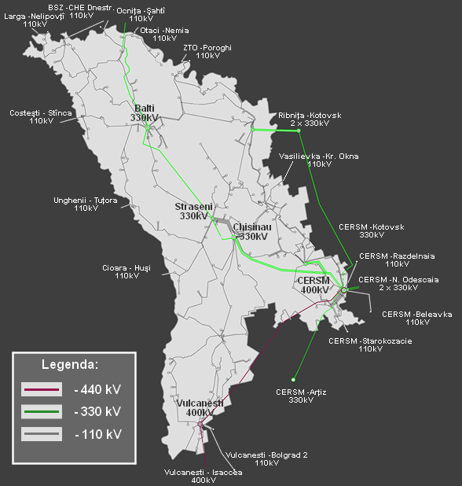

**Figure 7. Layout of the HV transmission network of the RoM**

**1.5. Technological and operational security of the power system**

### 1.5.1. Contractual arrangements

**36.** According to the Law on Electricity, the Electricity Market Rules and issued licenses each supplier of electricity at regulated tariffs should sign bilateral contracts for purchasing electricity at the lowest price that will enable it to cover the demand of all its final customers, and all such contracts should be notified to the regulator (NAER).

**37.** Electricity suppliers and eligible customers are bound to buy all electricity produced by CHPs, hydropower plants and RES PP on mainland which *de facto* represents all electricity produced on mainland at present. In this respect, Law on electricity provided creation of a Central Electricity Supplier (CES) that must purchase all electricity produced by CHP, HPP and RES PP and sell it to all suppliers and eligible customers, according to the market share.

**38.** For the remaining part of needed electricity the suppliers and eligible customers sign bilateral negotiated contracts typically on an annual basis. At present, in Moldova there are 3 active suppliers:

1. Furnizare Energie Electrica Nord JSC (FEEN), supplier on regulated tariffs;
2. FCC Gas Natural Fenosa Furnizare Energie LLC (GNFFE), supplier on regulated tariffs;
3. Energocom JSC, supplier on non-regulated tariffs.

FEEN is a state-owned company that was created as a result of unbundling of distribution and supply activities by RED North and RED North-West. GNFFE is a private company that was created by Gas Natural Fenosa as a result of unbundling of RED Union Fenosa`s distribution and supply activities. GNFE buys electricity from MGRES and from Energocom JSC. Energocom JSC is a state-owned company which imports electricity from Ukraine and buys electricity from Energokapital JSC (electricity from MGRES). All electricity that is purchased from Ukraine and from Energokapital JSC by Energocom JSC, is sold to FEEN, to GNFFE (including the electricity for balancing) and to eligible customers, according to the signed contracts.

**39.** All contracts on electricity purchase by suppliers from abroad should be presented to NAER for coordination and to the TSO (SE Moldelectrica) to be examined from the point of view of technical possibility to implement such contracts.

**40.** Each electricity supplier and eligible customer shall sign contracts with SE Moldelectrica for provision of transmission services by TSO and with distribution network operators for distribution services.

### 1.5.2. Purchase of electricity

**41.** Apart from electricity bought from MGRES as being part of the interconnected and synchronized IPS/UPS system, electricity import is technically also possible from Romania, however, only in island mode due to different frequency standards of ENTSO-E.

**42.** At present, the price for electricity purchased from MGRES is 0,0487 USD/kWh. In case of generation unit outage in MGRES, the load is covered by the Ukrainian power system.

**43.** Except Energocom JSC, there are 13 other independent electricity suppliers at non-regulated tariffs (licensed by NAER) that potentially could enter into the competition to provide cheaper electricity, either referred to base or balancing power. However, due to lack of credibility, financial strength of these suppliers as well as conditions of electricity export by Ukraine no contracts with them have been recorded until now.

### 1.5.3. System reserve

**44.** Due to its deficient power generation capacity on the mainland (approximately 300 MW available vs. 800 MW of the winter peak-load), very peculiar power generation conditions (heat demand driven CHPs and small-scale HPP with vulnerable hydrology) and involved technologies, mainland of the RoM has practically no power system reserve in winter and summer when the CHPs are generally out of operation due to no heat demand. All typical types of reserves envisaged in the Technical Norms of the Electricity transmission network (primary, secondary, fast tertiary and slow tertiary reserves) have to be consequently provided from outside (Ukraine) including frequency control services. MGRES may provide some reserves, however, by now there has been not such agreement established and prices negotiated. The Technical Norms also provide the conditions and requirements under which the reserves are provided.

### Reactive power compensation

**45.** For normal operation, the internal transmission network is sufficient for current consumption levels. However, during grid maintenance or grid outages there might appear some local or system power supply problems. Reactive power generated in the system (generators and power lines) is greater than the reactive load consumed and that imposes a need to implement the appropriate voltage control equipment, which is lacking at the moment. One of the local system problems refers to the southern part. When the 400 kV MGRES – Vulcanesti line is in maintenance it may appear situation when it is difficult to maintain the voltage level within the established limits.

As well, due to heavy integration of RoM power system in Ukrainian power system, there is a significant impact from UA system that may lead occasionally to too high or too low voltage levels in RoM, in which cases the Moldovan dispatcher lacks the required means to control the local voltage levels in Moldovan transmission system and is left with only one option – disconnection of HV lines in order to decrease the line charging.

### 1.5.5. Congestion management

**46.** NAER has developed a draft regulation on the allocation of capacities and congestion management mechanism on interconnections between the MPS and those of the neighboring power systems. The main elements of this document are the following:

1. The allocation of the available capacity on interconnectors is done by the TSO through auctions performed annually and monthly;
2. The allocation of interconnectors’ capacity is performed for each interconnector or for a group of interconnectors of the power system of the Republic of Moldova as follows: Republic of Moldova – Ukraine; Ukraine – Republic of Moldova. There will not be at initial phase the allocation of interconnections capacity for Republic of Moldova – Romania border;
3. Congestion management needs to ensure non-discrimination and should be based on market mechanisms that will provide efficient economic signals to the market participants and the TSOs;
4. TSO defines the capacity products for capacity allocation and the capacities available in cooperation with the neighboring TSOs;
5. Producers, suppliers, eligible customers and foreign legal entities that perform cross-border electricity exchanges may participate at the allocation of interconnectors’ capacity;
6. The interconnectors’ capacity that is not used will be re-allocated;
7. To ensure the transparency of the capacity allocation process the TSO will determine and publish on annual and monthly basis on its website: total available transmission capacity of each interconnector, net transmission capacity of each interconnector, allocated transmission capacity of each interconnector and transmission reserve margin. TSO coordinates all these figures with the TSOs of the neighboring countries.

The precondition for adoption of new regulation was prior promulgation of draft Law amending and supplementing Law on Electricity.

### 1.5.6. Electricity network losses

**47.** Approximately 70-75% of the energy sector equipment is worn out. During 2001-2010, losses in the electricity distribution networks dropped down from a level of over 29% (to a level of 13%, after the distribution network operators were bounded to invest in network and improve their performance under the regulations approved by NAER. In 2012, losses reported by the distribution network operators accounted for 11,93% ( Red North - 9,89%; RED North-West -11,9; RED Union Fenosa - 12,39%). In the period of 2013-2015 distribution losses continued to be reduced. So, in 2015 distribution losses dropped down to a level of 8,46% (RED North- 9,19%; RED North-West-9,32; RED Union Fenosa- 8,21% (Table 3).

**Table 3. Electricity losses in distribution system**

|  |  |  |  |  |  |  |  |  |
| --- | --- | --- | --- | --- | --- | --- | --- | --- |
|  | **2001** | **2005** | **2010** | **2011** | **2012** | **2013** | **2014** | **2015** |
| RED North | 28,4 | 14,39 | 10,43 | 9,89 | 9,89 | 9,83 | 8,53 | 9,19 |
| RED North-West | 39,9 | 20,07 | 12,98 | 12,39 | 11,9 | 11,7 | 11,3 | 9,32 |
| RED Union Fenosa | 28 | 21,44 | 13,68 | 13,11 | 12,39 | 10,75 | 9,45 | 8,21 |
| Total in distribution system | 29,21 | 20,16 | 13,06 | 12,5 | 11,93 | 10,68 | 9,46 | 8,46 |

*Note: * Includes technical and commercial losses*

**48.** It is obvious that the situation with losses improved tremendously in the last decade at all distribution network operators. Actual losses in the range between 28-40% still in 2001 were reduced to 8-9,5% in 2015. Further improvements are technically possible, however, only with considerable investments in the distribution system, which would consequently cause increase of regulated tariffs due to increased value of accounted assets.

### 1.5.7. Quality of services of distribution network operators

**49.** The quality of electricity distribution during 2013-2015 was assessed according to provisions of the Regulation on the quality of the electricity transmission and distribution services, approved by NAER Decision No. 406 of February 25, 2011. In 2017 will be approved new Regulation on the quality of the electricity transmission and distribution services according to Law on electricity No. 107 of May 27, 2016.

The analysis of the quality of electricity distribution service is carried out taking into account three basic aspects:

• the continuity of electricity supply to customers;

• resolving customer requests related to power quality;

• the quality of relations between distribution operators/suppliers and electricity customers.

**49.1.** *Continuity of electricity supply*. According to the Regulation, continuity of supply is analyzed using the general indicators of continuity (SAIDI, SAIFI and CAIDI), which reflect the general situation over the company regarding the unplanned (emergency) interruptions and guaranteed indicators which concern each end-consumer individually.  
Indicators of continuity are depending on the duration of interruptions, the number of consumers affected by the interruption and the total number of customers served by the distribution operator.

The SAIDI indicator reflects the average duration of interruption of power supplies in the system during the reported period and is calculated for interruptions generated by different fault reasons. The situation in the period of 2012-2015 for distribution operator is shown in Figure 8.

**Figure 8. Evolution of SAIDI indicators in 2012-2015 (minutes)**

According to the report of the European Council of Regulators in the Energy (CEER) "CEER Benchmarking Report 5.2 on the Continuity of Electricity Supply" published in February 2015, the level of the indicator SAIDI in different countries of the EU, in 2013, varies from 30 to 350 minutes. In this context, the indicators registered in Moldova in the year 2015 are comparable with some countries of UE.

Outside of the SAIDI indicator, distribution operators report annually the values of the SAIFI indicator – average frequency of interruptions in the network. The evolution of this indicator in the period 2007-2015 is presented in Figure 9.

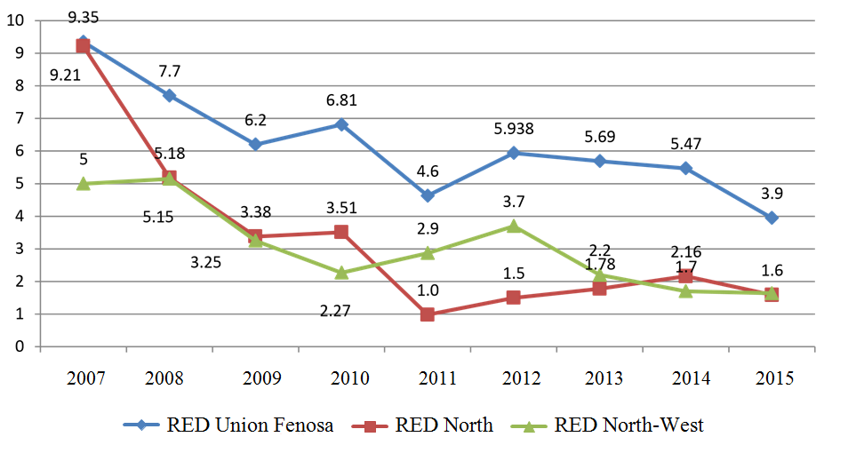

**Figure 9. Evolution of SAIFI indicators in 2007-2015**

From the data presented in Figure 9 it can be seen that in the year 2015 the SAIFI indicator was reduced for RED Union Fenosa and RED North-West, and remained at the same level for RED North.   
The value of the SAIFI indicator is directly influenced by the condition of the electrical networks – the worse the networks are, the more interruptions occur and the value of the SAIFI indicator will be higher. Improving the condition of networks involves investment in capital repairs and reconstruction of networks. So the value of the SAIFI indicator can be influenced by the network operators by adjusting the appropriate investment programs.

**49.2.** *Guaranteed continuity indicators*. Among general indicators, which if violated the distribution network operators might be penalized by NAER through tariff reductions, the Regulation also sets guaranteed indicators, which are set for each end-consumer individually. For instance, the Regulation sets the length of the permissible interruption (planned or unplanned), the permitted number of interruptions during a year etc.

From the reports submitted for 2015, there were 87883 cases when the electricity customers had the right to claim compensation from the distribution network operator for failing to comply with the allowed number of planned and unplanned interruptions. As compared to the previous year the number of such cases decreased by two times (reduced by 86 429 cases), which denotes a significant improvement in the continuity of electricity supply to final consumers. Though the Regulation provides payment of compensations to end-customers, for whom the allowed number of interruptions was exceeded, during 2015 were registered only 3 payment requests for compensations (two from REDUF and one from RED North with a small amount of payment).

The quality of electricity supplied to end-customers remains to be quite a serious problem. If expressed in monetary terms, this problem during 2012 caused the distribution network operators material damages in the amount of 724 884 MDL (34,683 EUR), among which RED UF paid to end-customers 691 966 MDL (33,108 EUR), and RED North – 32 918 MDL (1,575 EUR). In most cases, money was paid for repairing the customers electrical devices damaged following the electricity supply with violation of the established standard parameters.

* 1. **Electricity supply**

### 1.6.1. Diversity of electricity supply

**50.** Electricity is supplied to customers by 2 electricity suppliers (until 2015 -3 suppliers) at regulated tariffs, notably, GNFFU (early RED Union Fenosa) and FEEN (early RED North and RED North-West). Apart from that there are 15 wholesale suppliers at non-regulated tariffs, but in reality only two are active, one on the right bank of Nistru river (Energocom JSC), and one on the left bank (Transnistria) – Energokapital JSC. All suppliers are licensed by NAER.

**51.** Purchased volumes and electricity sales to final customers including the respective average prices in the last 3 years (2013-2015) are shown in Table 4.

**Table 4. Electricity purchased and supplied to final customers (mln. kWh)**

|  |  |  |  |  |  |  |  |  |
| --- | --- | --- | --- | --- | --- | --- | --- | --- |
| **Indicators** | **Unit** | **2013** | **2014** | **2015** | **Changes** | | | |
| ***2014/2013*** | | ***2015/2014*** | |
| ***Amount*** | ***%*** | ***Amount*** | ***%*** |
| Total purchased electricity by electricity suppliers | **mln. kWh** | 3, 959.7 | 4, 034.7 | 4, 050.4 | *+75.0* | *+1,9* | *+15.7* | *+0,4* |
| **mln. MDL** | 3, 903.9 | 4, 265.4 | 5, 383.3 | *+361.5* | *+9,3* | *+1, 118* | *+26,2* |
| Average price of purchased electricity | **bani/kWh** | 98.59 | 105.72 | 132.91 | *+71 3* | *+7,2* | *27.2* | *+25,7* |
| Total electricity supply to final customers (excl. eligible customers) | **mln. kWh** | 3.,435.2 | 3, 553.3 | 3, 616.2 | *+118.1* | *+3,4* | *+62.9* | *+1,8* |
| **mln. MDL** | 5, 386.7 | 5, 573.6 | 6, 066.6 | *+186.9* | *+3,5* | *+493.0* | *+8,9* |
| Average tariff for supplied electricity (*excl. VAT*) | **bani/kWh** | 156.81 | 156.86 | 167.76 | *+0.05* | *+0,0* | *+10.9* | *+6,9* |

*Note: MDL (Moldovan Lei), 1 MDL = 100 Bani*

**52.** All electricity suppliers, excluding the eligible customers, purchased in 2015 electricity in an amount of 4,050. mln. kWh (1.9% more than in 2014), while the amount of electricity supplied to final customers grew up by 3.4% compared to the previous year (3,393.9 mln. kWh) due to lower losses in the distribution network. The structure of consumption (with eligible customers) in the period of 2013-2015 is presented in Table 5.

|  |  |  |  |  |  |  |  |  |  |  |
| --- | --- | --- | --- | --- | --- | --- | --- | --- | --- | --- |
| **Table 5. The structure of electricity consumption by categories of customers** | | | | | | | | | | |
|  | **2013** | | **2014** | | **2015** | | **2014 / 2013** | | **2015 / 2014** | |
| **mln.** | **%** | **mln.** | **%** | **mln.** | **%** | **mln.** | **%** | **mln.** | **%** |
| **kWh** | **kWh** | **kWh** | **kWh** | **kWh** |
| **Total consumption** | 3 551,4 | 100 | 3 645,9 | 100 | 3717,2 | 100 | 94,5 | 2,7 | 71,3 | 1,9 |
| **Households - total** | 1 605,2 | 45,2 | 1 656,2 | 45,4 | 1 663,3 | 44,7 | 51 | 3,2 | 7,1 | 0,4 |
| **from which:** |  |  |  |  |  |  |  |  |  |  |
| urban | 876,4 | 24,7 | 887,3 | 24,3 | 879,8 | 23,7 | 10,9 | 1,2 | -7,5 | -0,8 |
| rural | 728,8 | 20,5 | 768,9 | 21,1 | 783,5 | 21,1 | 40,1 | 5,5 | 14,6 | 1,9 |
| **Non-households** | 1 946, 2 | 54,8 | 1 989,7 | 54,6 | 2 053,8 | 55,3 | 43,5 | 2,2 | 64,1 | 3,2 |

**53.** At the end of 2015, the three distribution system operators served a total number of 1,342,703 customers, of which 1,268,081 (99,4%) are households customers and 74,622 (5,6%) - non-household customers. The customers are served by RED Union Fenosa - 65%, RED North – 22% and RED North-West – 13%.

**54.** At the national level, the majority (99,6%) of customers’ installations are connected to low voltage electric networks. However, only 13 electric installations of customers are connected to 35 kV-110 kV lines and 5649 installations are connected to medium voltage lines of 6-10 kV.

**55.** In 2015, there is only one eligible customer that actually used its eligibility right and changed his electricity supplier.

**1.7. Peak power demand**

### 1.7.1. Peak power demand

**56.** Apart from 2 HPPs, electricity generation in TPPs and CHPs on both side of the Nistru River is based almost entirely on natural gas imported from Russian Federation via Ukraine. Therefore, there is practically neither fuel nor fuel-origin diversity in the RoM, which represents a considerable risk for the SoS.

**57.** The typical load variation in the winter season is between the minimal base load of 330-370 MW and the maximum peak-load of 700-760 MW, while in the summer season, it is in the range from min. 260 and max. 610MW. The maximum/minimal loads on characteristic working days (each 3rd Wednesday in month) by month in 2015 are shown in Figure 10 and load curves by month in Figure 11. The absolute annual power system peaks of 756 MW on 18/2/2015 at 19h and of 750 MW on December 16, 2015 at 18h were registered. The factor between the maximum peak-load and the minimal base-load is therefore more than two times (or more than 100%) both in winter as well as in summer period.



**Figure 10. Load variations on characteristic working days in 2015 (MW)**



**Figure 11. Load curves on characteristic working days in 2015 (MW)**

**58.** An example of an average daily load diagram for a month with the highest Pmin of 376 MW and absolute annual peak-demand of 756 MW on February 18, 2015 at 18:00 is shown in Figure 12, which demonstrates a typical demand – supply pattern for the RoM. Is necessary to note that, regardless of the increasing of energy consumption, in 2015 absolute annual peak-demand was lower compared to that in 2012 (836 on 2 February at 18-00 pm).



**Figure 12. Load diagram and meeting the demand on a day of absolute peak in 2015 (MW)**

**59.** The heat-demand driven CHP units (CET-1, CET-2 and CET Nord) as well as the only HPP Costesti operate solely in a base-load mode. The remaining part of the base-load and the variable part of the peak-load demand are met from purchases from MGRES and imports from Ukraine. While electricity production in MGRES demonstrates pretty standard electricity generation pattern of this power plant, which to a great extent tend to follow the load curve, the role of Ukraine is to fill the gaps and ensure balancing energy to the MPS. Sometimes part of production in MGRES is used also for electricity exports to Romania, which is implemented in an island mode

### 1.7.2. Power demand balancing instruments and associated risks

**60.** According to the Electricity Market Rules all suppliers of electricity at regulated tariffs and eligible customers must sign contracts for balancing energy with providers of balancing energy. At present, all balance-responsible parties, e.g. the 2 existing suppliers of electricity at regulated tariffs and the eligible customers, have signed contracts with Energocom JSC for balancing energy, which is provided from Ukraine.

**61.** The Law on electricity No. 107 of May 27, 2016 establishes a centralized balancing mechanism, where the balancing power/services would be ensured by the TSO (SE Moldelectrica) may lead to more efficient utilization of balancing energy providers and consequently, lower balancing costs. The Law on electricity also provides the creation in the future of an organized competitive electricity balancing market.

**1.8. Planned investments in new power system infrastructure**

### 1.8.1. Generally on investment environment

**62.** Under the Law on electricity, development of transmission and distribution networks is the obligation of system operators (TSOs and DSOs) based on long, medium and short term development plans, and investment plans that will be approved by NAER.

**63.** Development of new power plants will be done by private investors, following the tenders organized by GoM.

**64.** According to the existing tariff methodologies, the TSO and DSOs are obliged to invest at least the financial sources they collect under the depreciation component of the tariff. In the last tariff methodology that was approved by NAER, the appropriate amounts have been also established; however they are not linked to the value of depreciation.

**65.** Based on the existing legislation, the allocation of responsibilities between the institutions of central public administration (CPA) is as follows:

* 1. Permits for construction of new power plants exceeding capacity of 20 MW as well as for capacity increase of over 20 MW in the existing plants by GoM, which is also responsible for the organization of respective tenders (GoM);
  2. Approves national action plan on energy from renewable sources;
  3. Establish mechanisms, support schemes and incentives to achieve the objectives of state policy in the field of renewable energy (GoM);
  4. Approves Regulation on tendering for the status of eligible producer of electricity from renewable sources (by GoM);
  5. Approval of development and investment plans for transmission and distribution systems on long, medium and short terms (by NAER);
  6. Technical authorizations in the field of industrial security and certificate on equipment security to be used at the hazardous industrial objects (by MoE);
  7. Licenses to perform activities concerning generation, transmission; distribution and supply of electricity at regulated or non-regulated tariffs (by NAER);
  8. State ecological expertise and environmental impact assessment (by Ministry of Environment and its subdivisions);
  9. Planning certificates and construction authorizations for works / constructions of national interest public utility (by Ministry of Regional Development and Constructions and its subdivisions);
  10. Authorization for connection to the grid (TSO and DSO).

Local public authorities (LPA) are responsible for issuing planning certificates and construction authorizations.

### 1.8.2. Planned retirement of existing power generation capacities and planned new power generation projects and capacities

**66.** *Integration of RES-E electricity generation*.Integration of RES-E electricity generators into the MPS entails several issues, which may represent serious technical problems for operations of the MPS and may represent a risk for the SoS unless they are adequately solved in advance.

Existing conditions require the presence of the control tools for the TSO, the possibility of dispatching (control of active and reactive power generated, connect / disconnect, real-time voltage control, manual or automatic) and monitoring (electrical and character data collection technology in real time) of new power sources, both renewable and conventional as to ensure security of the national electricity system operation and compliance with contractual agreements.

Another uncertainty is the lack of data on wind potential, which would allow for a more optimal power system development planning. Lack of centralized RES integration (capacities and location) planning leads to the uncertainties within the project approval process. The absence of a regulated mechanism for prioritizing RES projects makes very problematic to plan the measures for strengthening the distribution/transmission grid.

The stability of the MPS strongly depends on the stability of the Ukrainian/CIS power system. The integration of large scale of intermittent RES-E generation like wind and solar farms combined with high electricity import scenario might lead to operational problems. The frequency control of the MPS is ensured by Ukrainian TSO. That is acceptable when balancing power needs are small, not exceeding around 50 MW. When this amount was higher, the present practice and the associated costs to cover it would not more be acceptable for Ukrainian power system. In order to overcome the problem there are only two solutions at the moment: (i) in non-existence of any balancing market, to pay for needed balancing power as asked for by Ukraine exercising a monopoly position, and which price would be much higher than regular electricity imports, or (ii) to disconnect whole regions of the MPS when the frequency cannot be maintained within the limits prescribed by relevant standards.

Potential large-scale integration of intermittent RES-E generation in Moldova will require significant changes in utilities’ operational practices. Improving conventional generation flexibility by adding faster response generation units and reducing minimum loading level on steam turbines is one potential solution. Additional methods may include incorporating wind and solar power forecasting into utilities’ day-ahead planning process. Other means of absorbing renewables’ variability, such as demand response and energy storage, can be used as well.

**67.** *Planned new power transmission projects and capacities*. Given its geographical position between two strong power systems of Romania and Ukraine, regional transmission network configuration, and power generation potential, Moldova has always held a strategic advantage, however, that was not fully exploited in the past decade. In the Energy Strategy 2030 the GoM sets its energy strategy priorities as strengthening the bidirectional transmission connections between the IPS/UPS and the ENTSO-E systems in order to enhance the position of Moldova as a power transit country, as well as the full commercial strengthening and exploitation of indigenous power generation capacities (MGRES and new plants in the future).

The diversification of power supply to Moldova has no other alternatives but the development of the power transmission network. The interconnection projects of Moldova with the EU internal power market through new power lines, as well as the strengthening of internal networks are essential, both for the supply security, and for the social welfare in Moldova.

The final benefit of the development and intensification of competition can be ensured only through participation in a larger energy market, a participation which will not arise for Moldova without an asynchronous / synchronous interconnection of its network with the ENTSO-E system. Connection with EU offers, along with an enhanced security, better prices on the market, given the perspective to improve competition, which will result at the end in a final energy price less onerous for Moldovan customers.

SE "Moldelectrica" ​​is continuously developing electric interfaces between RoM - Romania and RoM - Ukraine. In the last 10 years there were initiated and partially completed several feasibility studies aimed to determine the needed steps to increase electric security of the RoM. To this end they have been undertaken a number of actions, as:

- A feasibility study was elaborated for the construction of 400 kV OHL Balti-Suceava expanding power station Balti 330 kV after which the cost of building of the OHL (about 36 mln. EUR) was and also technical benefits after the completion of this construction.determined

- During the period 2014-2016, with EU support, it was elaborated a feasibility study for synchronous interconnection of energy systems of Moldova and Ukraine with ENTSO-E energy system, which aims to analyze technical possibilities of interconnection to the ENTSO-E system. This scenario is natural and consists of disconnecting the RoM and Ukraine energy systems from the IPS / UPS system and connection to ENTSO-E system.

In addition to the feasibility study for synchronous interconnection a feasibility study is performed for the interconnection of RoM and Romania energy systems through installing Back to Back stations (asynchronous interconnection). This scenario enables to maintain interconnection with Ukraine as well as to maintain energy exchanges with Romania. This study analyzes the following scenarios:

- Installation of a Back to Back station with a power up to 600 MW at Vulcăneşti and construction of a OHL Vulcăneşti-Chisinau (a strictly needed project). At the moment, the study is still ongoing, and about 200 million. EUR are estimated for investment.

- Installation of a Back to Back station with an output of 300 MW at Balti station and construction of 400 kV OHL Balti-Suceava, investment amount is estimated at about 90 mln. EUR. This project will complete the feasibility study elaborated in 2008-2009.

- Installation of a Back to Back station with an output of 300 MW and construction of 400 kV OHL Straseni-Ungheni-Iasi. At the moment the investment budget is not established, because it is not determined yet the connection point in Romania.

Based on those studies will be determined the best option for the development of interface with Romania, which will open the diversification of the electricity market in the RoM and the implementation of these projects will enable the accession to the ENTSO-E energy system in the future.

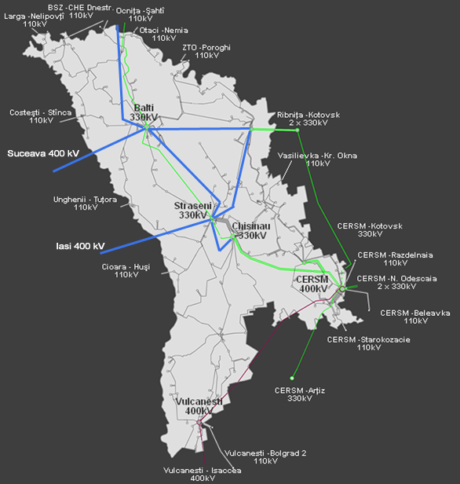

**Figure 13. Plans for new interconnections of Moldova with Romania and Ukraine**

As to the power interconnector with Ukraine, present congestions on the RoM – Ukraine interconnector limit the import from Ukraine as well as future power transit opportunities. To increase the capacity of the RoM – Ukraine interconnector, two power lines of 330kV Balti-CHE Dnestrovsk, of 123 km (87 km in Moldova) are needed (a second line 330kV Balti-CHE Dnestrovsk would allow to increase the import capacity trough “control interface”). The feasibility study for the Moldovan side has been completed. Costs are estimated at minimum 15 mill. EUR, of which 6 mill. EUR on the Ukrainian side and 9 mill. EUR on the Moldovan side. Like in the case of the previous project, the undertaking of any further steps will depend on the interconnection project to the ENTSO-E EC system, as well as on the final costs and funding possibilities.

As a continuation of the rehabilitation and consolidation works of the power transmission network, SE Moldelectrica has been upgrading the transmission network through financial assistances totaling 39.3 mill. EUR, of which EBRD loan - 14,3 mill. EUR, EIB loan - 17 mill. EUR and 8 mill. EUR grant offered by the Neighbourhood Investment Facility (NIF) of the EC.

The back-to-back solution is based on the existent line 400kV Vulcanesti-Isaccea, as a minimal solution, with extensions through the other two OHLs. In case of an asynchronous connection scenario, the 330kV OHL Balti – CHE Dnestrovsk represents an additional project, to extend import possibilities from Ukraine.

1. **Gas**

The description of Moldovan gas[4] system (MGS) shown in this document refers mainly to the territory located on the right bank of the Nistru River.

**2.1. Key market players and description of their role**

**68.** Key players in the gas sector are:

1. *Moldovagaz* *JSC* is a single vertically integrated company, thus having a monopoly position by controlling the entire chain of gas business (import, transit, transmission, wholesale supply, distribution and retail supply). It is designated as the national operator of the gas system and dominant supplier. It signs import contract with JSC Gazprom and an agreement for the use of gas storage in Ukraine. Its shareholders are JSC Gazprom (50%), central public administration of the RoM (36.6%), regional authorities of the Transnistria region (13.4%);
2. 2 transmission system operators in the right part of Moldova : *LLC* *Moldovatransgaz* ( subsidiary of Moldovagaz JSC) and *SE Vestmoldtransgaz* (state-owned company) that manages the new pipeline Iasi-Ungheni (interconnection with Romanian gas system);
3. 12 regional distribution system operators (all subsidiaries of Moldovagaz JSC);
4. 12 distribution system operators and suppliers at regulated tariffs;
5. 2 suppliers at nonregulated tariffs;
6. 1 transmission operator in the left part of Moldova (Transnistria) - *LLC Tiraspoltransgaz* (subsidiary of Moldovagaz JSC);
7. 5 distribution system operators in Transnistria (subsidiaries of LLC Tiraspoltransgaz).

**69.** According to the Rules of natural gas market, the status of the national operator of the gas system was assigned to Moldovagaz JSC. As per status of January 1, 2016, on the gas market there are 11 licensed suppliers operating at regulated tariffs, two at non-regulated tariffs, a transmission system operator (TSO) - LLC Moldovatransgaz and 23 licensees for natural gas distribution (Transnistria`s gas enterprises are not regulated from Moldovan authorities).

**70.** According to the NAER Decision no. 408 of 6 April 2011, the natural gas market in the RoM is determined as being uncompetitive because of a single import source, with imports being carried out by the supplier at regulated tariffs – Moldovagaz JSC.

**2.2. Regulatory framework**

**71.** The law on natural gas No. 108 of May 27, 2016, which transposes Directive 2009/73 / EC is the main law in the gas sector.

In addition, there are some decisions of NAER in the field of natural gas that are relevant:

1. Natural gas market rules;
2. Regulation on supply and use of natural gas;
3. Regulation on natural gas measuring for commercial purposes;
4. Regulation on extension of natural gas network;
5. Technical norms for gas transportation / transmission network;
6. Technical norms of gas distribution networks;
7. Methodology of calculation and application of natural gas tariffs;
8. Methodologies of calculation of natural gas losses in transportation and distribution networks, etc.

**2.3. Diversification of sources and gas supply networks**

**72.** There is quite poor diversification of primary energy supply in the RoM as natural gas represents more than 34.7% of the total primary energy supply of the mainland. Gas is supplied predominantly from Russia (in 2015 1007,4 mln. m3 or 99,9% of total) and only 0,1% (1,1 mil m3) gas imports from Romania through new pipeline interconnection Iasi - Ungheni that was put into operation in 2014.

**73.** Moldova is an important transit country for Russian natural gas, being on the route from Ukraine to Romania, Bulgaria and Turkey, including branches to Greece and FYR of Macedonia. The total length of Moldova’s three transit pipelines is 247 km (LLC Moldovatransgaz) with a total capacity of 34.6 bcm/y.

Another pipeline interconnection with Ukraine in the north of the country traverses through Moldova to connect two parts of the Ukrainian network. This pipeline, with a capacity of 9.1 bcm/y, has an important role in security of supply for Moldova, as it connects to the storage facilities Bogorodchany in Ukraine.

**74.** In practice, the capacity utilization rate of all cross-border pipelines is only about 45–55%, about 20 bcm/y of natural gas is transited through the Southern route and 1.3 – 2 bcm/y through the Northern route.

The national network is only partly used as well. The internal transmission network stretches over 1,550 km. There are no gas storage facilities in Moldova and there is no access to LNG.

**75.** It should be mentioned that actually all districts of RoM have access to natural gas, and 918 of localities from total of 1533 are gasified (59,9%).

**76.** Pipeline interconnection with Romania (Iasi-Ungheni) was put into operation in 2014 but currently it can be used only at a very low capacity level due to several technical constraints, which limit the amount of natural gas that can be injected in the Moldovan natural gas transmission system from this interconnection. In order to use the Iasi-Ungheni interconnection at the full capacity, it is necessary to develop the transmission gas pipeline Ungheni-Chisinau, which is planned to be built by the end of 2019.

**77.** Currently the priority regarding infrastructure development in gas sector of RoM is the project for the construction of the Ungheni-Chisinau pipeline.

This project provides for the construction of approx. 120 km of gas pipeline (Ø600mm) with an estimate budget of approx. 112 mln. EUR. The Moldovan authorities plan to complete this project at the end of the year 2019. The funding is expected to be from loans and a component of grant, which will be contracted by the IFIs.

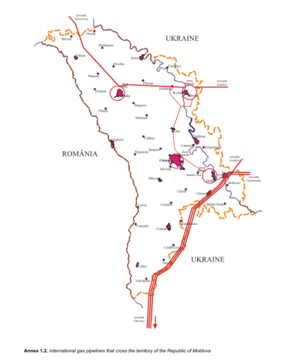

**Figure 14. Natural gas pipeline over the RoM territory**

Thus, real connection of the Moldovan natural gas transmission system to the system of Romania will be fully feasible not earlier than in 2019, with the short-term objective to offer gas supply alternatives in emergency situations and the long-term strategic objective to benefit from the existing Romanian connections with other European country.

**78.** At the same time it is necessary to be taken into account that interconnection with Romania will be fully feasible if the Gas Pumping Station (on the territory of Romania) will be constructed and Romanian gas transmission network will be strengthened in the region.

**2.4. Technological security and quality and level of network maintenance**

**79.** The Regulation on the quality of natural gas transmission and distribution service was approved by NAER on June 9, 2011 and was implemented starting with November 11, 2011.

According to license holder’s reports on quality indicators for 2015, which were submitted to NAER, all companies related to Moldovagaz group registered 1323 planned interruptions, compared to 1672 interruptions registered in 2013. The network operators reported that in all these cases the reconnection was carried out in due time according to Regulation, which led to an overall performance indicator of 100%. All cases of interruptions were announced by the network operators in advance, with at least 3 days before that, which corresponds to requirements established by NAER Regulation.

Among other network operators, which do not belong to the Moldovagaz group, 59 planned interruptions were reported, all of them being announced in advance and solved in time, according to existing requirements.

**80.** The duration of planned interruption are presented in Table 6.

**Table 6. Duration of planning interruptions in gas sector,** **2015**

|  |  |  |  |  |  |
| --- | --- | --- | --- | --- | --- |
|  | **Total planning interruptions** | **of which up to:** | | | |
| **24 h** | **48 h** | **72 h** | **120 h** |
| **Total by sector** | 1382 | 1225 | 42 | 36 | 29 |
|  | 100,0 % | 88,6 % | 3,0 % | 2,6 % | 2,0 % |
| **DSO Moldovagaz** | 1323 | 1166 | 42 | 36 | 29 |
| 100,0 % | 88,1 % | 3,2 % | 2,7 % | 2,2 % |
| **Other DSO** | 59 | 59 | - | - | - |
| 100,0 % | 100,0 % | - | - | - |

**81.** The total number of registered unplanned interruptions in 2015 was 246, compared to 360 interruptions in 2013 registered by companies affiliated to Moldovagaz group. All other DSOs registered 29 unplanned interruptions in 2015. Duration of unplanned interruptions is indicated in Table 7.

**Table 7. Duration of unplanned interruptions in gas sector,** **2015**

|  |  |  |  |  |  |
| --- | --- | --- | --- | --- | --- |
|  | **Total unplanned interruptions** | **Of which up to:** | | | |
| **36 h** | **54 h** | **72 h** | **120 h** |
| **Total by sector** | 246 | 243 | 1 |  | 2 |
| 100,0 % | 98,8 % | 0,4 % | - | 0,8 % |
| **DSOs of Moldovagaz group** | 217 | 214 | 1 | - | 2 |
| 100,0 % | 98,6 % | 0,5 % | - | 0,9 % |
| 88,2 % | 88,2 % | 100,0 % | - | 100,0 % |
| **Other DSOs** | 29 | 29 | - | - | - |
| 100,0 % | 100,0 % | - |  | - |
| 11,8 % | 11,8 % | - | - | - |

**82.** In 2015 al DSOs received 9399 connection requests, of which more than 94% were accepted and around 6% were refused. The most connection requests were received by DSO of Moldovagaz group (94%) Detailed information regarding connection requests are presented in Table 8.

**Table 8. Connection requests to the gas distribution networks in 2015**

|  |  |  |  |
| --- | --- | --- | --- |
|  | **Total connection requests** | **Of which:** | |
| **accepted** | **refused** |
| **Total gas sector** | 9690 | 9119 | 571 |
| 100,0 % | 94,1 % | 5,9 % |
| **DSOs of Moldovagaz group** | 9399 | 8828 | 571 |
| 97,0 % | 94,0 % | 100,0 % |
| **Other DSOs** | 291 | 291 | - |
| 3,0 % | 6,0 % | - |

**83. Development and investment plans of TSO and DSOs related to Moldovagaz group**. According to the provisions of new Law on natural gas TSO and DSO shall perform the development of the natural gas transmission (distribution) networks in relation to increasing demand for natural gas, so as to ensure the reliability and continuity of supply to consumers with natural. Efficient development costs for the development of natural gas networks shall be borne by the TSO/DSO and shall be taken into account when setting tariffs for natural gas transmission/distribution service, when they have been performed in accordance with license conditions, methodology for calculating tariffs and the Regulation on principles of planning, approval and making investments in the natural gas sector and on the way of their recovering through tariff, issued by the NAER.

In the context of this obligation, TSO/DSO is obliged to develop and, after prior consultation with market participants concerned, to submit to the NAER for approval a development plan for the transmission networks for the next ten years (for the distribution network - for three years). When drafting the network development plans, system operators must take into account the energy strategy, approved by the Government and statistical data on energy balance, the current and projected supply and demand. These development plans must include effective measures to ensure the reliability of natural gas system and the security of natural gas supply. The development plans must include effective measures to ensure the reliability of natural gas system and natural gas supply security, and inform natural gas market participants about the main gas transmission/distribution networks, which are expected to be rebuilt or rehabilitated in the next decade, must contain information on the investments that were already established, and identify new investments, which must be made within three years, and shall provide a time frame for implementing all investment projects.

Also, TSO and DSOs are required to develop and implement annual investment plans, approved by NAER. According to the objectives of TSO and DSOs related to Moldovagaz group investments will be allocated to existing infrastructure, particularly in technical and technological development of delivery systems, e.g. reconstruction, modernization of existing installations and objects, in particular:

1. replacement of existing gas distribution stations with the new generation of automated service that provides all the technological processes;
2. modernization of gas transmission and distribution systems for monitoring processes;
3. linear control valve mounting systems, telemetry and monitoring systems for cathodic protection of underground steel gas pipelines for the safe operation of the gas system;
4. replacement units for gas flow in modern electronic impulse;
5. development of new natural gas distribution pipeline in localities that are already connected to the gas supply system that will offer possibility to connect to the distribution network new customers and to increase deliveries of natural gas;
6. continuing of capital reparation of the transmission gas pipeline Razdelinaia -Ismail, etc.

But, taking into consideration the financial situation of the TSO, DSO and the general financial situation of Moldovagaz JSC (with a debt to Gazprom JSC over 11 billion MDL), it is very problematic to plan major investments in the system that are strictly necessary for ensuring continuity of gas supply to consumers.

The implementation of investments depends on several key factors including effective development of macro-economic indices of the RoM as well as adequacy of tariff policy of NAER, natural gas market situation, solvency of TSO, DSO and Moldovagaz JSC and its ability to collects payments from its customers.

**2.5. Security of supply and sector functioning under the state of emergency circumstances**

**84.** The law on natural gas No. 108 of May, 27 2016 provides the necessary principles and basic rules regulating the duties and behavior of the natural gas market participants in case of emergency situations, coordination of activities in the natural gas sector, as well as the actions to be taken in case of effective disruptions in the supply of natural gas.

**85.** Ensuring security of natural gas supply lies within the competence of the Government of RoM, which shall approve the Regulation on emergencies on the natural gas market, the Preventive Action Plan and the Action Plan for emergencies on the natural gas market, and the structure of the Commission for Emergency surveillance on the natural gas market.

Regulation on emergencies on the natural gas market and the Action Plan for emergencies on the natural gas market must include unequivocal, transparent and non-discriminatory measures, which shall not affect competition and the functioning of the natural gas market, other than in justified cases.

**86.** Regulation on emergencies on the natural gas market shall be approved by GoM and it shall define the roles and functions of the natural gas market participants, establish minimum safety standards in the supply of natural gas, and shall contain, in particular, the following:

1. criteria for identifying protected customers;
2. measures to be taken by natural gas undertaking in order to ensure gas supply to protected customers in the following cases:

i) in extreme temperatures, recorded during the peak period of seven calendar days, statistically occurring every 20 years;

ii) during any period, if during at least 30 calendar days the demand for natural gas is exceptionally high, which statistically occurs every 20 years;

iii) during any period, if during at least 30 calendar days the major natural gas networks are affected in normal winter conditions.

1. criteria for identifying natural gas undertakings, that will supply gas to protected customers and criteria for identifying different categories of major risks to the security of natural gas supply;
2. risk reduction measures in case of disruption of natural gas supply, which implies disruption of natural gas infrastructure or gas supply source/route in case of an exceptionally high demand for natural gas;
3. content of the report to be presented by natural gas undertakings on the security of natural gas supply and other obligations, imposed on natural gas undertakings and other authorities, competent entities, including obligations regarding secure operation of the natural gas system.

**87.** Action plan for emergencies on the natural gas market shall be approved by GoM and it shall contain the following:

1. define crisis levels;
2. determine the role and functions MoE, of natural gas undertakings, of the Commission for emergency surveillance on the natural gas market, of other responsible authorities, and of industrial gas customers, taking into account differences to the extent that these are affected in case of interruption in natural gas supply, and establish ways and means of interaction of the latter with the central body of public administration, specialized in the energy field, with Commission for emergency surveillance in the natural gas market for each of the crisis levels defined;
3. identify, where appropriate, measures and actions for reducing the potential impact of disruption in the natural gas supply on the heating system and the supply of electricity, produced using natural gas;
4. lay down detailed measures and procedures that must be followed for each crisis level, including schemes for ensuring information flow, including for enabling the natural gas undertakings and industrial natural gas consumers to react to each crisis level;
5. identify measures that are not based on market mechanisms to be implemented in the occurrence of emergency situations and evaluate the extent, to which the use of these measures is needed for solving situations, arising in a crisis, identify their effects and define the procedures, necessary for their implementation;
6. describe the mechanisms, applied for cooperation with countries that are Parties to the Energy Community in the occurrence of crises, at every level of crisis;
7. describe the details of the reporting obligation, imposed on natural gas undertakings in case of alert for each of the crisis levels;
8. establish a list of predefined actions to be taken for ensuring natural gas supply in emergency situations, including commercial agreements between the parties, involved in such actions, and the compensation mechanisms for natural gas undertakings, list of discontinued final customers and the order, by which natural gas supply to final customers shall be limited and/or stopped, etc.

**88.** Also the Law on natural gas provides that when developing the Action Plan, the following factors should be taken into consideration:

1. the need to ensure natural gas transmission capacities in order to enable uptake and delivery of natural gas volumes to risk areas;
2. the need to extend the natural gas transmission networks;
3. the flexibility of the natural gas system;
4. the possibility of using alternative reserve fuels by industrial consumers and producers of electricity and heat;
5. the need to develop the interconnection capacity to enable cross-border exchanges of natural gas;
6. cooperation and coordination of activities of TSO and DSO;
7. the possibility of diversifying natural gas supply sources;
8. the need to optimize investments in infrastructure in order to expand transmission capacities, replace the networks with the expired service life in order to reduce losses of natural gas, to secure natural gas supply, and to diversify imports of natural gas from different possible sources, including from regasification terminals and bidirectional interconnections.

**2.6. Gas import and supply**

**89.** The RoM is a net importer of natural gas that represents a major source of fuel, the natural gas participation in the total primary energy supply being approximately 34,7%.

**90.** Table 9 shows the amounts of natural gas purchased and supplied to final customers on the mainland of the RoM, both distributed to the end-customers and directly supplied through transmission networks.

**Table 9. Natural gas purchased and supplied to final customers in 2001-2015**

|  |  |  |  |  |  |  |  |  |  |  |  |
| --- | --- | --- | --- | --- | --- | --- | --- | --- | --- | --- | --- |
| **Indicators** | **Unit** | **2001** | **2005** | **2010** | **2013** | **2014** | **2015** | **Changes** | | | |
| **2014/2013** | | **2015/2014** | |
| **Amount** | **%** | **Amount** | **%** |
| 1. Purchase of natural gas – total | **mln. m3** | 1 127,0 | 1 418, 6 | 1 187, 8 | 1 031,2 | 1 053,1 | 1008,5* | +21,9 | +2,1 | -44,6 | -4,2 |
| **mln. MDL** | 1 131,8 | 1 364, 9 | 3 674, 0 | 4 922,2 | 5 658,7 | 4 847,3 | +736,5 | +15,0 | 811,4 | -14,3 |
| 2. Average price of natural gas purchased | **$/1000 m3** | 78,0 | 76,1 | 250,1 | 379,6 | 377,1 | 256,0 | -2,5 | -0,7 | 121,1 | -32,1 |
| **MDL/1000 m3** | 1 004 | 962 | 3 093 | 4 773 | 5 373 | 4 806 | +600 | +12,6 | -567 | -10,6 |
| 3. Supply of natural gas (through distribution and transmission networks) - total | **mln. m3** | 1 108,5 | 1 315, 0 | 1 089, 8 | 945,3 | 959,0 | 927,6 | +13,6 | +1,4 | -31,4 | -3,3 |
| **mln. MDL** | 1 004,0 | 1 551, 0 | 4 362, 2 | 5 786,7 | 5 867,3 | 5 794,0 | +80,6 | +1,4 | -73,3 | -1,2 |
| 4. Average tariff for natural gas supplied (including *VAT*) | **MDL/1000 m3** | 906 | 1 180 | 4 003 | 6 121 | 6 118 | 6 246 | -3,0 | -0,0 | +128 | +2,1 |

*Note: * In 2015 gas import was done from Russia 1007,4 mln.m3 and from Romania 1,1 mln. m3*

In 2015, as in the previous period, the main supplier of natural gas in Moldova was Moldovagaz JSC, that imported 1007,4 mln. m3 natural gas (99,9% of total import) from Gazprom JSC, Russia. In 2015, the second importer of natural gas in Moldova was Energocom JSC, which delivered 1,1 mln. m3 gas (0,1%) from Romania. Compared with the previous year, the import of natural gas was reduced by 4,2%.

**91.** Level of consumption in Moldova mostly depends on the level of supply tariffs, which in turn depends on two main factors: the price of imported gas and the exchange rate of MDL/$.Thus, during the period of 2010-2015 the annual import price increased by 3,3 times (from 76,1 $/1000 m3 to 250,1 $/1000 m3), the local average supply tariff increased more than 4,3 times and as a result, the natural gas consumption by final customers decrease by 17% (from 1315 mln. m3 to 1090 mln. m3). This trend continued in 2011-2015.

**92.** In 2011- 2014 import price increased from 339,3$/1000 m3 in 2011 to 377,1 $/1000 m3 in 2014 (11,1%). But expressed in MDL, the import price increase by 34,2% given the fact that in this period the exchange rate of MDL increase by 20,8% (from 11,8 MDL/$ to 14,25 MDL/$).

**93.** In 2015, the purchase price of imported natural gas decreased by 32,1% (from 377,1 $/1000 m3 in 2014 to 256$/1000 m3 in 2015). But in the same time the exchange rate of MDL increase by 31,7% (from 14,25 MDL/$ to 18,77 MDL/$). As a result, the average annual tariff increased by 2,1% in compared to 2014. Evolution of supply tariffs in Moldova in the period of 1997 – 2015 (in MDL and $) is shown in Figure 15.

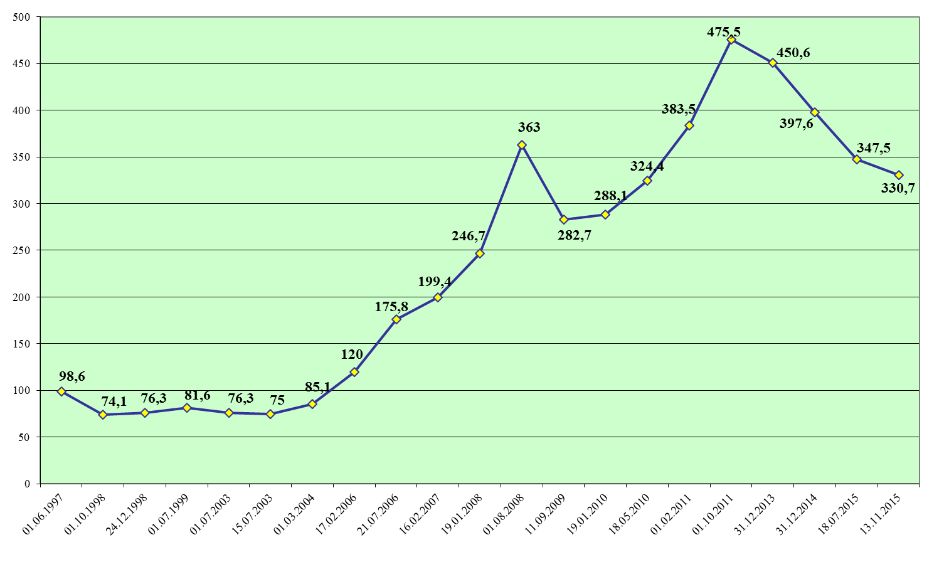

**Figure 15. Evolution of gas supply tariffs in 1997-2015, $/1000 m3**

As shown, during the period from 1997 (first tariff approval by NAER) to 2015, average supply tariffs in MDL increased more than 13,7 time. In US dollars tariffs increase only 3,4 times. Such big difference is explained by the depreciation of MDL more than 4 times.

Consumption by final customers of natural gas in 2015 was around 927,6 mln.m3 which is lower by 3,3% compared to 2014 and lower than by 12,5% compared to 2011.

In 2015, the amount of natural gas delivered to final customers from transmission system was 19,1 mln. m3, while the amount of natural gas delivered from the distribution systems - 908,5 mln. m3.

**94.** It should be noted that the share of each company in the natural gas market of Moldova is different because the number of consumers of each company is different. In the same time, the structure of consumers and their consumption level is different as well. The shares of different distribution companies in the natural gas market of RoM are presented in Figure 16.

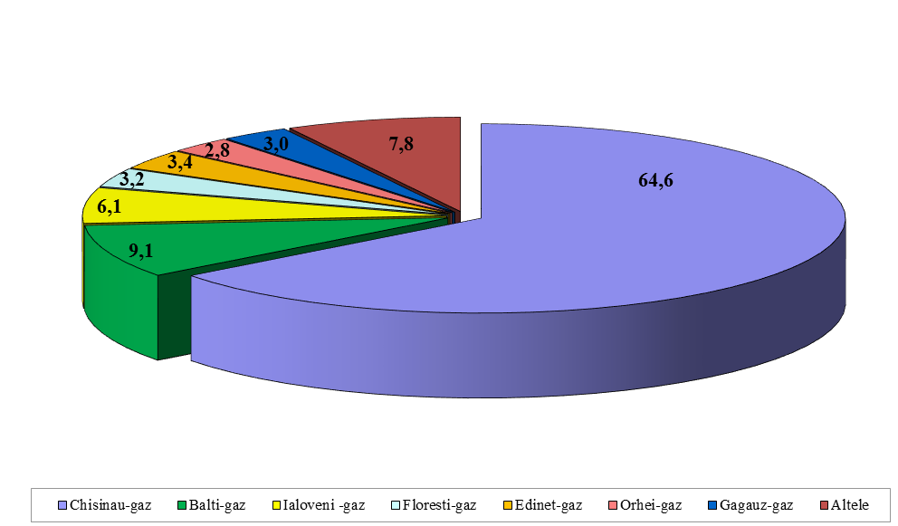

**Figure 16. Companies share in the gas market of Moldova in 2015, %**

**2.7. Gas consumption**

**95.** As shown in Figure 16, natural gas consumption is concentrated in the capital of RoM - Chisinau, which consumes 64,6% of the total amount of natural gas, and in Balti, which consumes 9.1% of total consumption in RoM. Natural gas consumed in Moldova is mainly used for electricity and heat production.

**96.** Moldova has a very high share of natural gas used in total primary energy consumption (34,7%) and is among the countries with the highest share of natural gas in electricity and heat production (accounting more than 90%).

**98.** In the context of the general decrease of the natural gas consumption in 2015, it is to be noted that for the energy sector category, natural gas consumption went up by 0,3%.The relevant decrease was registered for the category of “other economic agents” (industry, agriculture, transport, construction, etc.), where the consumption decreased by 11,2%. For households, the decrease was about 2,0% (Table 10) despite the fact that in 2015 and in previous years TSO and DSOs related to Moldovagaz group has developed new natural gas distribution networks, to which new consumers were connected.

**Table 10. Composition of final natural gas consumption by consumer categories**

|  |  |  |  |  |  |  |  |  |  |  |
| --- | --- | --- | --- | --- | --- | --- | --- | --- | --- | --- |
| **Consumer categories** | **2013** | | **2014** | | **2015** | | **2014 / 2013** | | **2015 / 2014** | |
| **mln. m3** | **%** | **mln. m3** | **%** | **mln. m3** | **%** | **mln.m3** | **%** | **mln.m3** | **%** |
| Total final natural gas consumption, *of which:* | 945,4 | 100.0 | 959,0 | 100.0 | 927,6 | 100.0 | +13,6 | +1,4 | -31,4 | -33 |
| - Households | 278,1 | 29,4 | 277,1 | 28,9 | 271,6 | 29,3 | -1,0 | -0,3 | -5,5 | -2,0 |
| - Public institutions | 42,8 | 4,5 | 42,7 | 4,4 | 42,7 | 4,6 | +0,3 | +0,6 | 0 | 0 |
| - Energy sector | 393,5 | 41,6 | 396,9 | 41,4 | 398,1 | 42,9 | +3,4 | +0,9 | +1,2 | +0,3 |
| - Other economic agents | 231,4 | 24,5 | 241,3 | 25,3 | 215,2 | 23,2 | +10,9 | +4,7 | -27,1 | -11,2 |

**99.** In the structure of gas consumption in 2015 the largest share of 43% belongs to the energy sector customers (CHP and Heat Plant) which increased by 2 percentage points, when compared to 2014. The share of the household customers was 29%, which was the same in previous 2 years, but decreased when compared to 2009-2012. The share of other economic agents (except for those from the energy sector) was 23%, which diminished by 2% due to the most significant decrease per categories. It should be emphasized that the share of the natural gas consumption which belong to public institutions during the reference period remained in the interval of 4-5 %.

**2.8. Implementation of the 3rd Enery Package in the gas sector**

**100.** Moldova is a member of the Energy Community and committed to implement the 2nd and 3rd Energy Packages. In order to ensure a better coordination of the implementation process, the GoM developed a Roadmap that is aimed to implement the respective commitments during 2013 – 2020.

**101.** The Law on Natural Gas (No. 123 of 2009) established the basic legislative framework for the gas market in line with the 2nd Energy Package, in particular, with Directive 2003/55/EC.

**102.** As described above the law on natural gas No. 108 of May 27, 2016, which transposes Directive 2009/73/EC concerning common rules for the internal market in natural gas, the EU Directive 2004/67/EC concerning measures to safeguard security of natural gas supply, and the EU Regulation No. 715/2009 on conditions for access to the natural gas transmission networks. This Law provided full implementation of 3rd Energy Package gradually by 2020[5].

**103.** In 2013 Moldovagaz JSC started to reorganize distribution companies and, first of all Chisinau-gas LLC, which is one of the biggest from 12 regional distribution system operators (all subsidiaries of Moldovagaz JSC). Moldovagaz JSC took over the supply activity and Chisinau-gas LLC remained only a distribution company (distribution operator), providing distribution services only. Later, starting with January 2016, all other distribution companies of Moldovagaz JSC were unbundled and the supply service is provided only by Moldovagaz JSC. All 12 Moldovagaz JSC subsidiaries operate only as distribution network operators.

**104.** It should be mentioned that the implementation process of the Third legislative Package in the natural gas sector of the RoM has to be considered in the context of the current, as well as medium and short-term developments, on the ground of the existing contractual and ownership realities in the country.

**105.** Regarding unbundling of the TSO, the new Law on natural gas provides three models as options, as it is established in Directive 2009/73/EC: (1) ownership unbundling, (2) Independent System Operator (ISO) and (3) Independent Transmission Operator (ITO).

Nevertheless, the authorities of the RoM came to the conclusion that the implementation of any of the 3 models provided in the EU Directive 2009/73 is linked today to specific difficulties, which might jeopardize not only the implementation process, but the overall economic, financial, political and social developments of the country. Nonetheless, possible failure in the implementation of unbundling of Moldovagaz JSC could have irremediable adverse implications, therefore the issue denotes most serious risk both for the SoS of the country, as well as the SOS in the neighboring countries from the region, taking into consideration the fact that the territory of the RoM is crossed by transit pipelines through which Gazprom transits natural gas to other countries from South-Eastern Europe.

**106.** Taking into account the perspective for implementation of the 3rd Energy Package, and in order to have guarantees for the assets from the gas sector of the RoM, Gazprom JSC has conditioned the position regarding the clarification of situation concerning its assets in Moldovagaz JSC.

**107.** It should be noted that the previous longer-term contract between Moldovagaz JSC and Gazprom JSC expired in 2011. Since then the parties have not succeeded to renegotiate and sign a new long term contract so each year the previous agreement is being extended on an annual basis. All negotiations for a new contract were disturbed by discussions on the implementation of the 3rd Energy Package, including threats for possible stoppage of gas deliveries to Moldova.

**108.** Since 2011, RoM has negotiated with the Russian side a new energy cooperation framework and, first of all, on a long term gas supply agreement and regarding the legal separation of the debt for the gas supplied in the RoM and Transnistria region, as well its restructuring, which currently represents about more than 6 bill. US$, of which more than 87% is the debt of the Transnistrian region.

**109.** Consolidation of the outstanding debt as explained above needs consideration of all possible options on how the very complicated situation could be remedied, which involves complex reforms in several involved sectors: gas, power and district heating.

**110.** Therefore, having regard to Moldova's special situation, and based on Decision D/2012/04/MC-EnC, Moldova obtained derogation on postponement of implementation of Article 9 of Directive 2009/73/EC concerning common rules for the internal market in natural gas and repealing Directive 2003/55/EC by 1 January 2020. It was a positive decision for the Moldovan gas sector’s development.

1. *Source:* National Bureau of Statistics. The energy balance does not cover the left bank of Moldova (Transnistria).
2. Denotes gross inland energy consumption including energy used in transformations (e.g. power plants, CHPs etc.), losses of energy transportation systems to final customers and final energy consumption.
3. *Source:* NAER report, 2015
4. The term “gas” in this section refers entirely to natural gas. Other gases that can be used in the gas sector supply chain (e.g. LNG, biogas, synthetic gases, various types of derived gases etc.) are not developed yet in the RoM, therefore not covered in the report.
5. Based on Decision D/2012/04/MC-EnC, Moldova achieved derogation on postponement of implementation of Article 9 of Directive 2009/73/EC by 1 January 2020