Engagement planning for development of the Resilient Strategy Chisinau 2023-2030

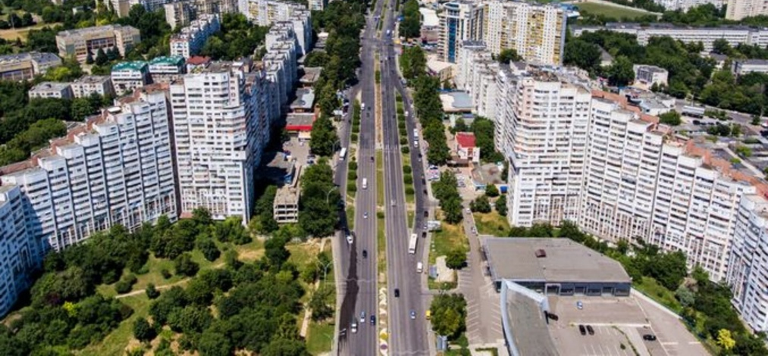

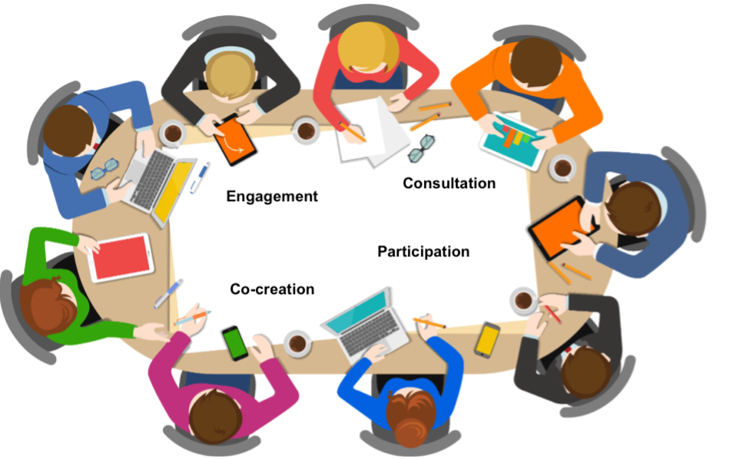

March 2023

Chisinau Municipality
Table of Contents
I. introduction 3
II. key takeaways from inception workshop 4
III. tools for engagement with stakeholders at the local level 6
3.1 Online survey: Chisinau Resilience Strategy 8
3.2 Communication through social networks 12
3.3 International development partners meetings 12
3.4 Public consultations 13
IV. timeline 13
V. list of main stakeholders 14

I. introduction

Local authorities deliver services, make decisions and operate in ways that directly affect the daily lives of all residents. Citizens, in the 21 century, have an expectation that all decisions should be focused on their priorities, problems and needs. To ensure a proper alignment between citizen's needs and public officials priorities, local authorities must involve local community in the decision-making process. It is essential for local authorities to seek, to listen and to respond to all suggestions, ideas and input from citizens, civil society representatives and other community stakeholders.

Public participation requires much more than simply publishing a project on the authority's website, as is often the case. Mimicking consultations creates a misunderstanding of what citizen participation really means. Moreover, organizing citizen engagement events without a full understanding of the factors that determine successful participation can have a negative effect by reducing trust in authorities and undermining the social contract between citizens and public authorities.

Citizens know best the community in which they and their families want to live. They have a vision concerning the quality and quantity of public services provided by local authorities. And the quality and diversity of these services is one of the determining factors of the citizens' standard of living. Therefore, the decisions and public policies implemented by the authorities affect the way citizens perceive and evaluate the activity of the local administration.

Thus, the commitment to develop and implement Chisinau's Resilience Strategy must also come with instruments to ensure a participatory and transparent process throughout the entire life span of the document. Engagement exercises should include diverse interested parties: national and local public authorities, private sector, civil society, citizens, academic environment and development partners.

The objective of this engagement plan is to increase community's participation in the development of the new Strategy, by ensuring validation and efficient feedback mechanisms for each step.
- Citizen and stakeholder participation is a way to improve the quality of the documents and to ensure continual commitment for its implementation.
- Genuine participation can only take place when there is a partnership between the local public authority and the citizens/community.
This engagement plan will provide an overview of important elements that Chisinau authority must take into account when planning the exercise of community involvement in the development of the Strategy. The plan contains techniques and participation methods that can be used at the different stages and steps of strategy development. Recommendations will be offered for organizing a process that is as inclusive as possible, ensuring authentic involvement and engagement of all relevant stakeholders.

II. key takeaways from inception workshop

Chisinau municipality, in 2021, was the first city in the Republic of Moldova to join the UNDRR flagship initiative – Making Cities Resilient 2030 and the first city to run the Preliminary and Detailed Disaster Resilience Scorecard assessments, as well as the Public Health System Resilience assessment scorecard contributing to informing recovery and build back better efforts in the COVID-19 crisis context.

Building upon the findings and recommendations of the previous evaluations, Chisinau initiated the preparation of a new Resilience Strategy for the period 2023-2030. The inception workshop was organized on February 16th, 2023. The workshop marked the official launch of the strategic planning process and reconfirmed the high level commitment from the political leadership of the local authority.

The involvement of local communities and stakeholders is key to developing a Strategy which will meet the needs of citizens and to understand the main threats to resilience that must be tackled in the upcoming public policy document.

Top three conclusions and ideas generated at the workshop were:
1) Draft vision for the new Strategy
2) Strengths and weaknesses of resilience measures in Chisinau
3) Main essentials that must be addressed in the new Strategy

- Vision: The municipality of Chisinau is a safe and sustainable city for everyone at all times.
In the upcoming seven years Chisinau will make every effort to become an innovative resilience hub, supporting other municipalities within the country, but also outside the national boundary, advocating and promoting resilience in view of enhancing local socio-economic development.

- Strengths and weaknesses of resilience measures in Chisinau

Table 1.
Strengths | Weaknesses
Human resource potential - In contrast with other cities and villages, where the number of population is decreasing, Chisinau registers positive growth. | Lack of qualitative data.  Gaps in collection, systematization, processing and record of data.
Decent governance structure at the local level to ensure good implementation of resilience building. | Lack of sustainable and reliable channels of communication with citizens/communities.
Response plans in place (e.g. medical emergency) | Despite having a good potential in terms of human resources in Chisinau, significant gaps exist in their preparedness and capacity to intervene.
Strong commitment for developing the green infrastructure in Chisinau (e.g. massive tree planting campaigns) | Poor information of the local population on risks and intervention measures to increase resilience. The population is not a full partner of the local authority in the implementation of the 2030 agenda.
The existence of development partners, international projects and periodic exchanges of experience with other cities in Europe. | Uneven distribution of medical institutions.
 | Poor funding. Regulatory restrictions, which significantly reduce the fiscal space of institutions.
 | There is no policy of securing strategic reserves: food, medicine, diesel.
 | Corruption - leads to poor construction standards and violation of the provisions of zonal urban plans.
 | No capacities to deploy mobile hospitals.
 | No mechanisms to ensure systemic assessment of human resources regarding the level of stress and training.
 | Poor communication between central and local authorities.
 | Risk scenarios are not updated to current realities.
 | Low involvement of authorities with control functions in the field of environmental protection.

- Main essentials

Table 2.
 | Main essentials that must be included in the Strategy
Highest priority | Essential 3 : Strengthen financial capacity for resilience
 | Essential 6: Strengthen Institutional Capacity for Resilience
 | Essential 8: Increase Infrastructure Resilience
Medium priority | Essential 4: Pursue resilient urban development and design | Essential 1: Organize for disaster resilience
 | Essential 9: Ensure Effective Preparedness and Disaster Response | Essential 2: Identify, understand, and use current and future risk scenarios

III. tools for engagement with stakeholders at the local level

The involvement of civil society and citizens, especially those representing the affected categories, as well as other stakeholders throughout the entire process of developing policy documents is important both, to ensure a process of consultation and data validation, and to be assured that the principle of leaving no one behind is respected. Wide consultation must be ensured throughout the entire process of developing the new Strategy.

The public consultations will be conducted according to the provisions of Law no. 239/2008 regarding transparency in the decision-making process and Government Decision no. 967/2016 regarding the public consultation mechanism with civil society in the decision-making process. This will ensure that the requirements for consultations are respected throughout the development of the document and not just at an advanced stage when the document is finalized.

The UN recommendations regarding the consultation of society, including socially-vulnerable groups several levels of public consultations, as follows:

In order to ensure an authentic engagement the following steps are recommended:

- Designation of a coordinator responsible for managing all consultative and informative processes relevant to the development of the Resilience Strategy.

- Establishing the purpose of the engagement exercises:
  - Improving community knowledge regarding resilience.
  - Obtaining new ideas and proposals from the community.
  - Dissemination of relevant information and progress in developing the Resilience Strategy.

Planning and organization of an activity may require a significant effort. Thus the establishment of the goal of each individual activity will increase the efficiency of the efforts made by local public authority.

- Identification of target groups. The essential ingredient for a value-added activity is the participation of the general public. Thus, the activities are to ensure equal treatment of all people, including disadvantaged, vulnerable or marginalized people.
Groups of people who should be involved in Strategy development are:
- Socially vulnerable people: poor groups.
- Representatives of institutions: school, medical, sports, cultural.
- Representatives of interest groups: civil society, civic activists, religious groups, trade unions, native associations, migrants.
- Representatives of international donor community: UNDP, EU delegation, International Organization for Migration, World Bank, European Bank for Reconstruction and Development, etc.
- Various demographic groups: young people, women and the elderly.
- Representatives of the business environment: developers, entrepreneurs; representatives of commercial organizations;

- Planning financial resources. Any information and citizen involvement event involves certain financial costs. Without the identification and budgeting of these costs, it will be difficult to ensure the sustainability of the process of informing citizens about the development and the implementation of the Resilience Strategy.

3.1 Online survey: Chisinau Resilience Strategy
The online survey will be used in order to validate with the general public the initial results and outcomes from the inception workshop organized in February 2023 with main City Hall stakeholders. On top of it, it will also allow for additional gathering of data and insights from the local community regarding preparedness and ability to respond to various shocks and stresses. The survey will help identify potential areas for improvement, including specific actions that can be taken to build resilience at the local level. Participation of the general public in these survey will serve as an additional support for the development of an effective resilience strategy.

Questions for online survey
Section 1: General information
- What is your age?
  - Under 18
  - 18 - 35
  - 36 - 59
  - 60 - 69
  - 70 or older
- What is your gender?
  - Male
  - Female
- What is your occupation?
  - Student
  - Employed
  - Self-employed
  - Retired
  - Unemployed
  - Other
- How long have you lived in Chisinau?
  - Less than 1 year
  - 1 - 5 years
  - 6 - 10 years
  - More than 10 years
- How do you rate "Quality of life" in the municipality of Chisinau?
  - Very good
  - Pretty good
  - Neither nor - neutral
  - Not so good
  - Not good at all

Questions for online survey
Section 2: Chisinau overall resilience
- In your opinion, what are the most significant shock and stresses that Chisinau faces? (select all that apply)
  - Natural disasters (e.g. floods, earthquakes)
  - Infrastructure failures (e.g. power outages, water shortages, bridge failures)
  - Limited food supplies
  - Poor shelter facilities
  - Health pandemics
  - Other (please specify)
- How prepared do you feel Chisinau is to respond to shocks and stresses?
  - Very prepared
  - Somewhat prepared
  - Neither nor - neutral
  - Somewhat unprepared
  - Very unprepared
- How would you rate the engagement of local authority with citizens and civil society regarding resilience building in Chisinau?
  - Very good
  - Pretty good
  - Neither nor - neutral
  - Not so good
  - Not good at all
- In your opinion, what are the strengths of Chisinau that can help the city respond to various shocks and stresses?
- Strong community networks
- Resilient infrastructure
- Effective emergency response systems
- Prepared human resources
- Good local governance structure
- Dialogue between local authority and central authorities
- Other ( please specify)

Questions for online survey
Section 3: Resilience Strategy Chisinau 2023 - 2030
- In your opinion, what should be the top priorities for Chisinau Resilience Strategy? (select up to three)
  - Strengthen financial capacity for resilience
  - Strengthen institutional capacity for resilience
  - Increase infrastructure resilience
  - Ensure effective preparedness and disaster response
  - Strengthening community networks and engagement
  - Other (please specify)
- How important is it you that the new Resilience Strategy addresses the following emerging issues?
  - Climate change and environmental sustainability
  - Addressing public health and healthcare access
  - Reducing inequality and social disparity
  - Strengthening governance at the local level
  - Economic development
  - Other (please specify)
- How likely are you to support the implementation of the new Resilience Strategy?
  - Very likely
  - Somewhat likely
  - Neither nor - neutral
  - Somewhat unlikely
  - Very unlikely
- How do you see yourself contributing to the implementation of the new Resilience Strategy?
- Any other identified problems or additional comments and suggestions.

3.2 Communication through social networks

Throughout the development process of the new strategy, Chisinau local authority should use social networks inform citizens about both, the progress on the new strategy, but also about general measures taken by the authority to build resilience. A more active use of social networks can increase awareness about resilience, including sharing of innovative examples and case studies from other cities and regions. Chisinau local authority could publish two-three posts per month that have a direct connection to the process of development of the new strategy:
- Latest news/updated on progress in developing the strategy. After adoption of the strategy, it will inform the public about the implementation of the strategy and about any issues and challenges that could affect the results.
- A more detailed presentation of the 10 essentials and the connection between the essentials and the activities carried out by the local authorities and municipal enterprises.
- Information on how the local budgets contributes to building local resilience.
- Success stories from other cities related to resilience measures.
All information must be short, interesting, easy to share and published regularly.

3.3 International development partners meetings

Donor meetings will be used in order to ensure alignment with strategic objectives of the international development partners and to build support and funding for the activities that will be included in the new strategy. These discussions will help identify new partnerships and solidify actual partnerships that can contribute to positive change and development of local resilience.

Potential partners: UN System (UNDP, ION, World Bank, etc.) EU delegation, European Bank for Reconstruction and Development, etc.

Examples of ongoing projects that have a resilience component:

- Ungheni and Cahul municipalities are part of the EU4Moldova - Focal regions project. Project started in 2019 and will run to 2024. Total budget USD 26 million (mostly administered by UNDP). The project supports the strengthening of economic, territorial and social cohesion, by facilitating inclusive and sustainable local socio-economic growth and improving the living standards of citizens in these respective regions.
- Balti and Ungheni are part of the Moldova Sustainable Green Cities project. Project started in 2018 and will run to 2023. Focus areas: Climate Change, Environment & Energy. The objective of the project is to catalyze investments in low carbon green urban development based on integrated urban planning approach by encouraging innovation, participatory planning and partnerships between a variety of public and private sector entities.

3.4 Public consultations

The participation of citizens other interested parties should not be ensured only at the last stages of drafting the strategy. Most of the time, consultations are limited only to the publication of an advanced version of the document on the web, without using other engagement activities for involved of interested parties. It is important for local authorities to make additional effort to ensure authentic and meaningful participation of citizens, civil society and other interested parties at various milestones in order to ensure adequate time to incorporate their feedback in the strategy. Thus, at least two rounds of consultations (online and/or physical format) of the document will be organized with all relevant stakeholders. Public hearings will be used to obtain opinions and ideas of local residents on priorities and strategic areas. Additionally, public hearings can be used as an avenue to highlight how the budget solves community's problems and how it contributes to building resilience.

IV. timeline

- Online questionnaire: April 1 - April 22
- Communication on social media: continuous activity throughout the drafting of the new strategy
- International development partners: April - May
  - Potential partners: Potential partners: UN System (UNDP, ION, World Bank, etc.) EU delegation, European Bank for Reconstruction and Development, etc.
- Public consultations:
  - 1st hearing: end of April (after processing information from the online questionnaire)
  - 2nd hearing: early June (after advancing in drafting of the strategy, but still enough time to allow relevant changes after stakeholders feedback.

V. list of main stakeholders

City Departments
- General department for social work and health
- General department for education, youth and sport
- Municipal department for the protection of the rights of the child
- Representative of the Municipal Council
- Deputy Mayors Office
- Advisors of the General Mayor
International organizations
- UN system (UNDP, International Organization for Migration, World Bank, etc.)
- EU delegation
- European Bank for Reconstruction and Development
Healthcare sector representatives
- Municipal Clinical Hospital for children
- Municipal Clinical Hospital for adults
- Territorial medical associations (Ciocana, Botanica, Riscani sector)
- Chisinau Public Health Center within the National Public Health Agency
- Chisinau Regional Department of Emergency Medical Care
Municipal enterprises
- Chisinau Electric Transport Municipal Company
- Municipal Enterprise Green Spaces
Private companies
- I.C.S. Premier Energy SRL (electricity supplier in Chisinau municipality)
- Orange (telecommunication company)
Central authorities
- General Inspectorate for Emergency Situations
Civil society organizations and citizens (general public)

